Name: - Bhavesh Goswami
Module 5 – Introduction to DBMS
lab exercises:-
- Introduction to SQL
Lab 1: Create a new database named school_db and a table called students with the following columns: student_id, student_name, age, class, and address.
- CREATE DATABASE school_db;
- CREATE TABLE student
(
student_id int AUTO_INCREMENT PRIMARY KEY,
student_name varchar(50),
student_age int ,
student_class int,
student_address varchar(100)
);
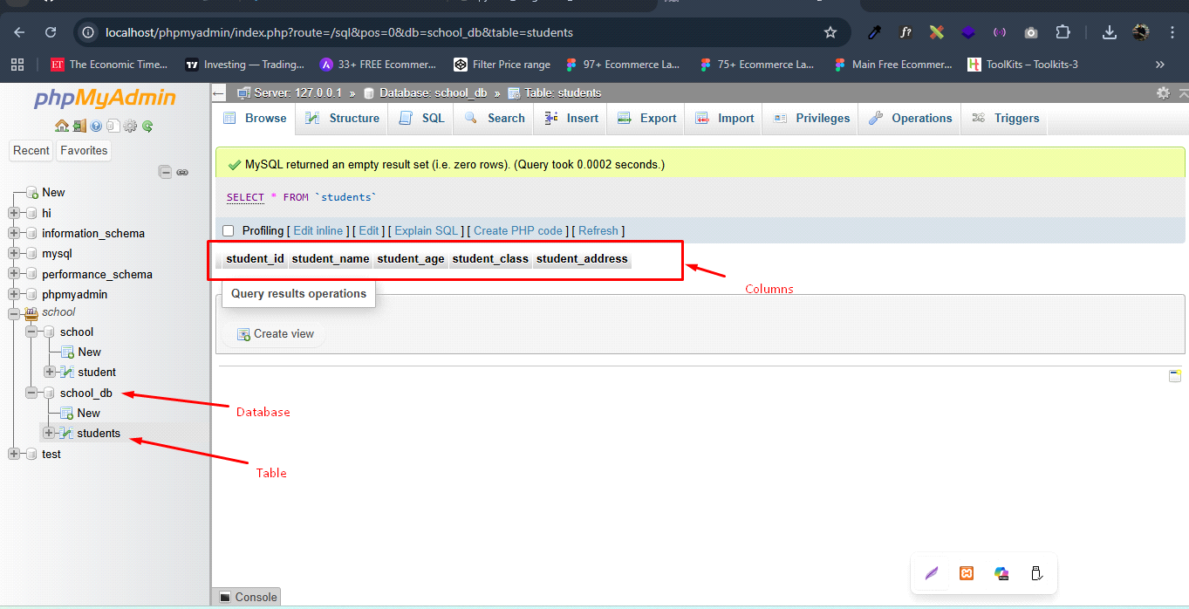

Lab 2: Insert five records into the students table and retrieve all records using the SELECT statement.
- INSERT INTO students(student_name, student_age, student_class, student_address)
VALUES
('Bhavesh Goswami', 25, 12, 'B-230, subbham socity, Ahmedabad'),
('Ketan Patel', 23, 11,'B-320, subbham socity, Ahmedabad'),
('Raj Pandey', 26, 12, 'D-101, Kundan socity, Ahmedabad'),
('Mayank Rathod', 22, 10, 'C-426, Kundan socity, Ahmedabad'),
('Raju Barot', 27, 12, 'A-230, subbham socity, Ahmedabad');
- SELECT * FROM students;

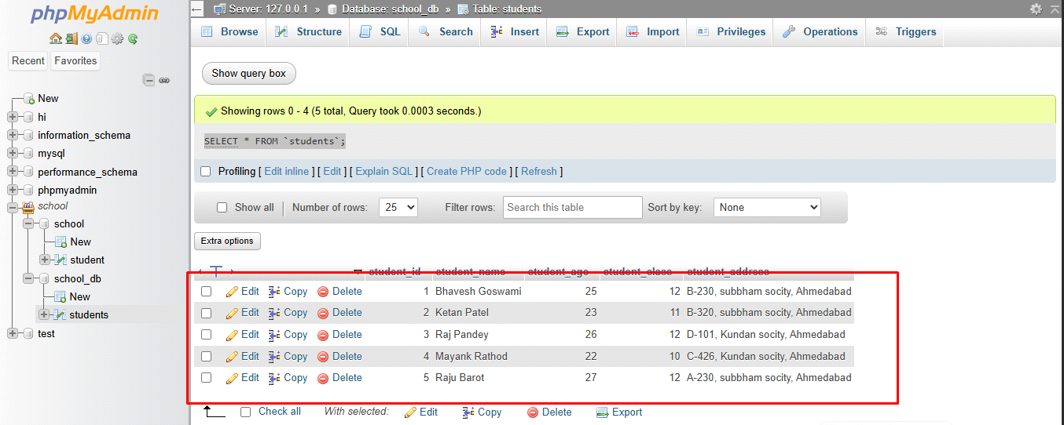

2. SQL Syntax
Lab 1: Write SQL queries to retrieve specific columns (student_name and age) from the students table.
- SELECT student_name, student_age FROM students;
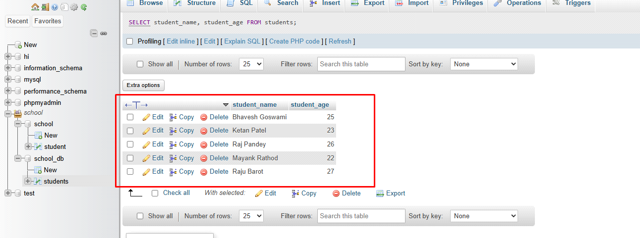

Lab 2: Write SQL queries to retrieve all students whose age is greater than 10.
- SELECT * FROM students
WHERE student_age > 10;
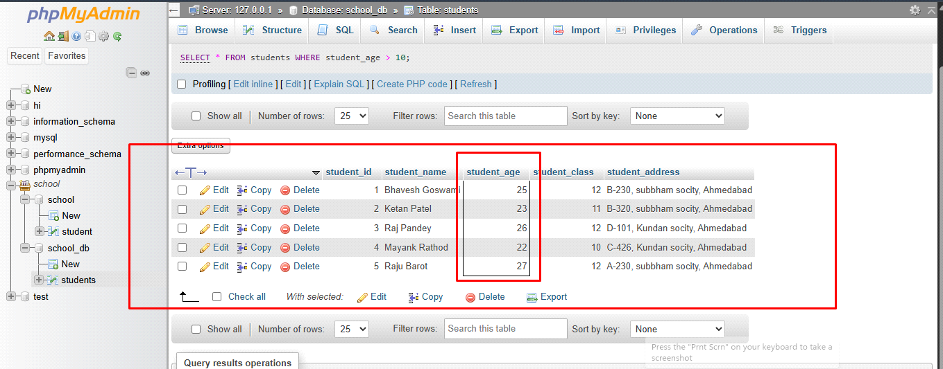
- SQL Constraints
Lab 1: Create a table teachers with the following columns: teacher_id (Primary Key), teacher_name (NOT NULL), subject (NOT NULL), and email (UNIQUE).
- CREATE TABLE teachers
(
teacher_id INT PRIMARY KEY,
teacher_name varchar(50) NOT NULL,
subject varchar(20) NOT NULL,
email varchar(50) UNIQUE
);

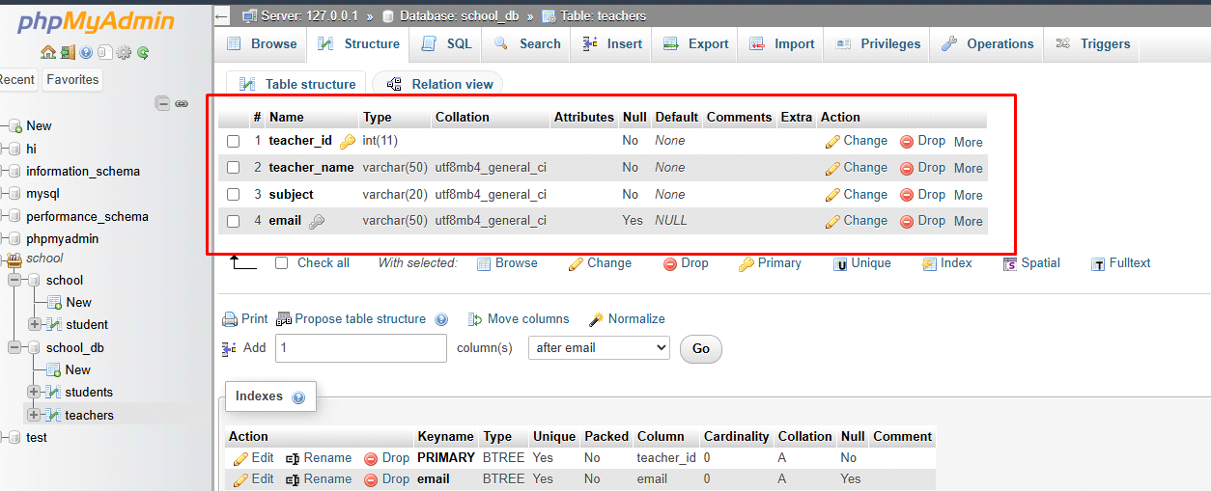
Lab 2: Implement a FOREIGN KEY constraint to relate the teacher_id from the teachers table with the students table.
CREATE DATABASE school_db;

CREATE TABLE teachers (
teacher_id INT PRIMARY KEY,
teacher_name VARCHAR(50) NOT NULL,
subject VARCHAR(50) NOT NULL,
email VARCHAR(100) UNIQUE
);

CREATE TABLE students (
student_id INT PRIMARY KEY AUTO_INCREMENT,
student_name VARCHAR(50),
teacher_id INT,
FOREIGN KEY (teacher_id) REFERENCES teachers(teacher_id)
);

INSERT INTO teachers (teacher_id, teacher_name, subject, email)
VALUES
(1, 'Saurabh Patel', 'Math', 'saurabh@gmail.com'),
(2, 'Raj Patel', 'Science', 'patel@gmail.com'),
(3, 'Bhargav', 'English', 'bhargav@gmail.com');

INSERT INTO students (student_name, teacher_id)
VALUES
('Rahul', 1),
('Amit', 2),
('Neha', 1),
('Priya', 3),
('Karan', 2);

SELECT
students.student_id,
students.student_name,
teachers.teacher_name
FROM students
INNER JOIN teachers
ON teachers.teacher_id = students.teacher_id;
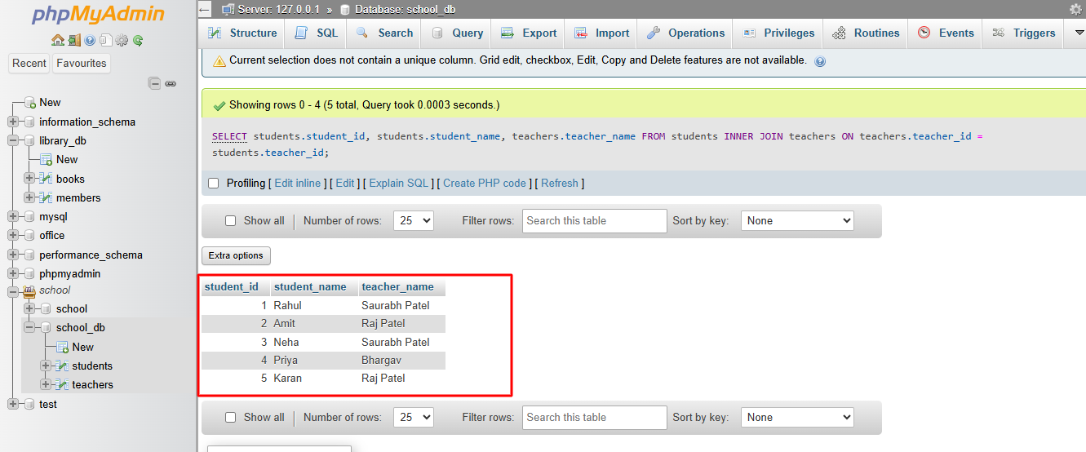

- Main SQL Commands and Sub-commands (DDL)
Lab 1: Create a table courses with columns: course_id, course_name, and course_credits. Set the course_id as the primary key.
- CREATE TABLE courses
(
Courses_id int PRIMARY KEY,
courses_name varchar(20),
courses_credit INT
)

Lab 2: Use the CREATE command to create a database university_db.
- CREATE DATABASE university_db;
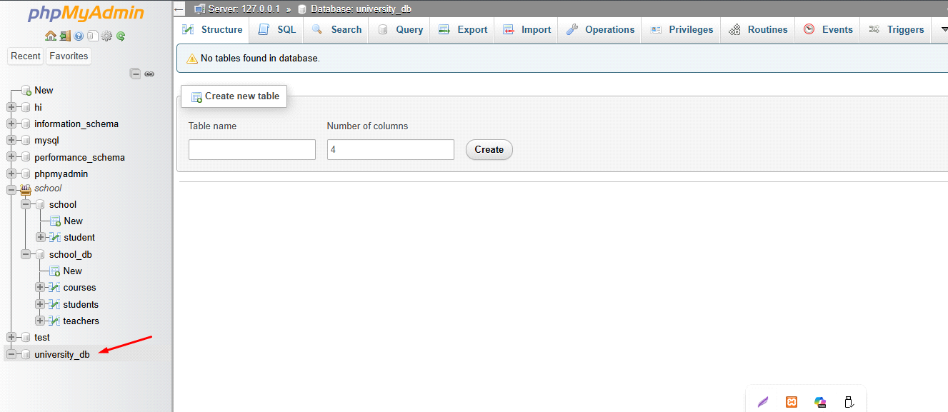
- ALTER Command
Lab 1: Modify the courses table by adding a column course_duration using the ALTER command.
- ALTER TABLE courses
ADD COLUMN course_duration INT;
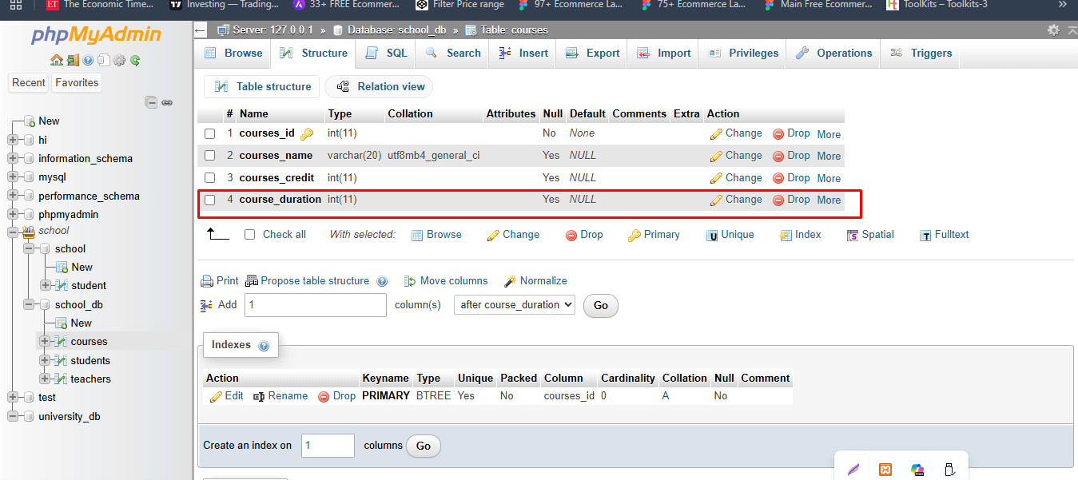

Lab 2: Drop the course_credits column from the courses table.
- ALTER TABLE courses
DROP courses_credit;
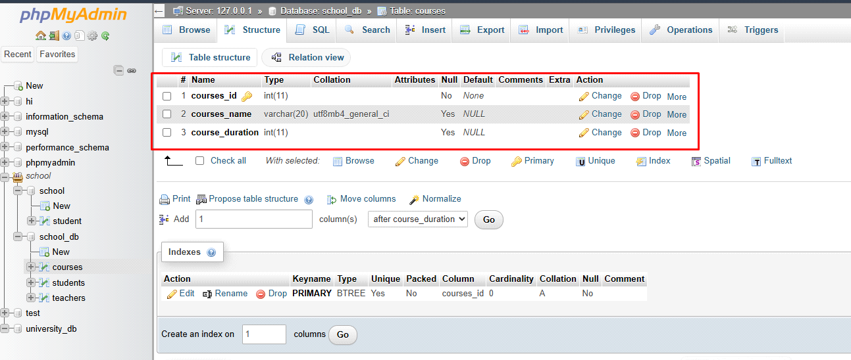
- DROP Command
Lab 1: Drop the teachers table from the school_db database.
-DROP TABLE teachers;
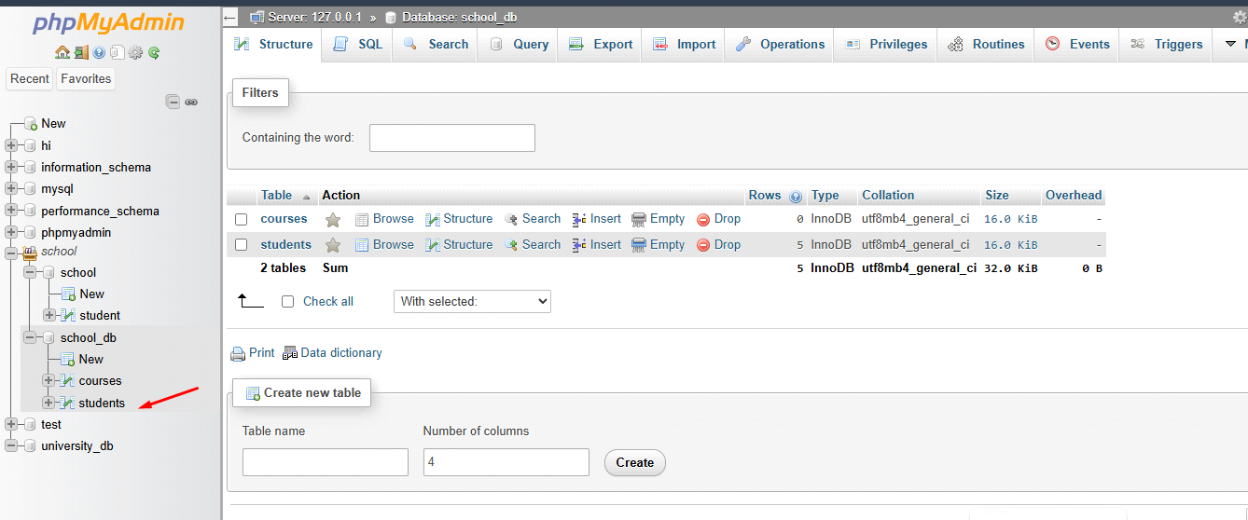

Lab 2: Drop the students table from the school_db database and verify that the table has been removed.
- DROP TABLE students;
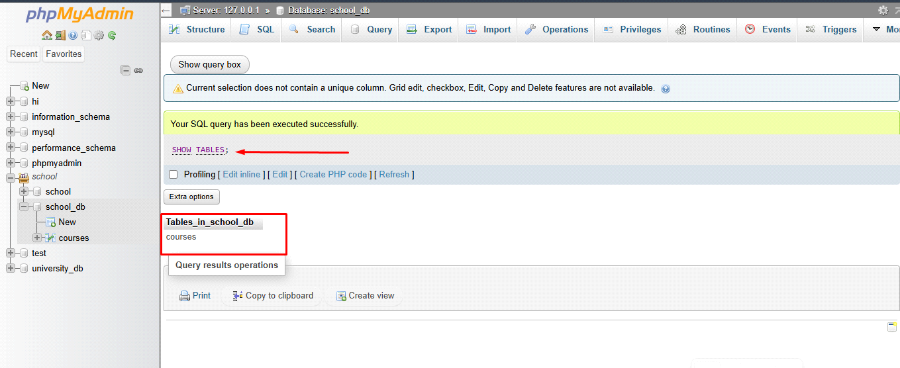
- Data Manipulation Language (DML)
Lab 1: Insert three records into the courses table using the INSERT command.
- INSERT INTO courses(courses_name, course_duration)
VALUES
('c', '3 month'),
('SQL', '2 month'),
('python', '4 month'),
('java', '6 month');
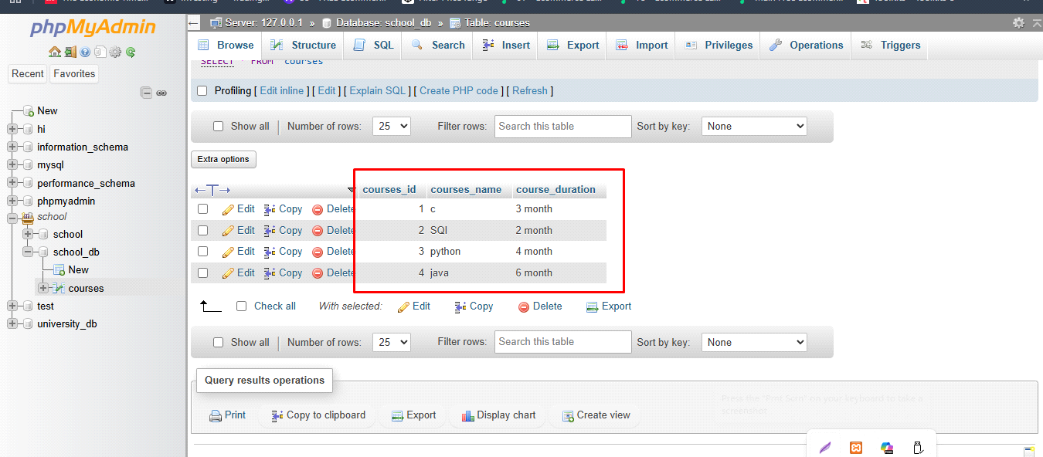
Lab 2: Update the course duration of a specific course using the UPDATE command.
- UPDATE courses
SET course_duration = '6 month'
WHERE courses_id = 3;
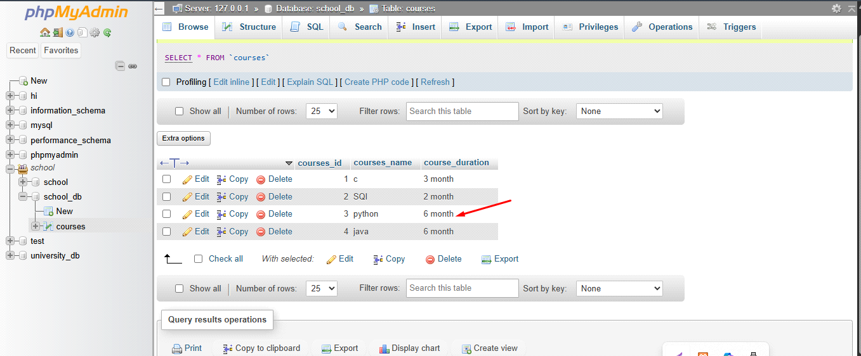
Lab 3: Delete a course with a specific course_id from the courses table using the DELETE command.
- DELETE FROM courses
WHERE courses_id = 4;
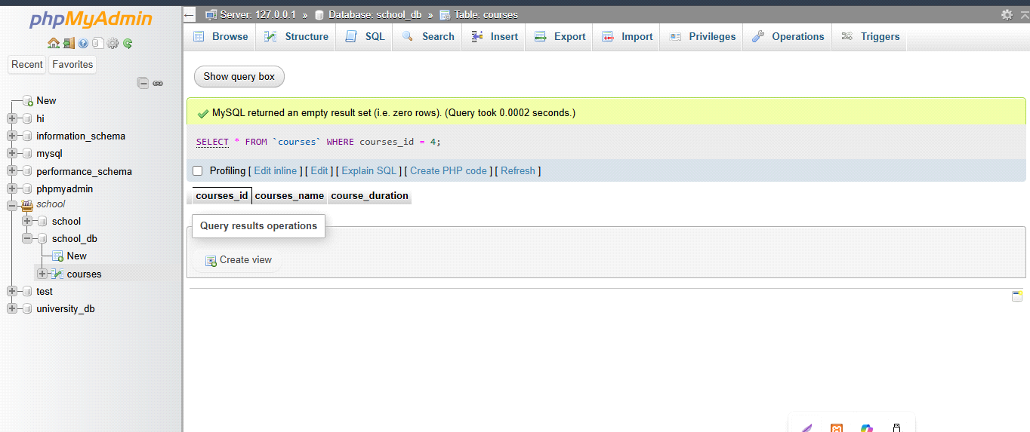

8. Data Query Language (DQL)
Lab 1: Retrieve all courses from the courses table using the SELECT statement.
- SELECT * FROM courses;
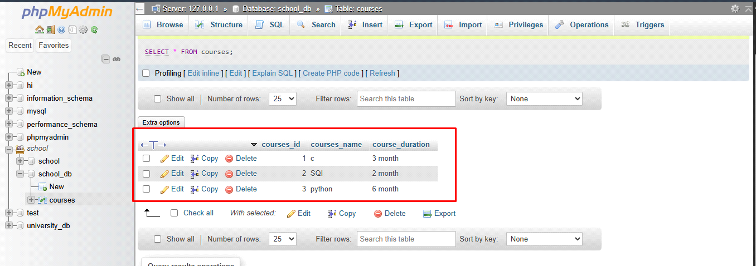
Lab 2: Sort the courses based on course_duration in descending order using ORDER BY.
- SELECT * FROM `courses`
ORDER by course_duration DESC;
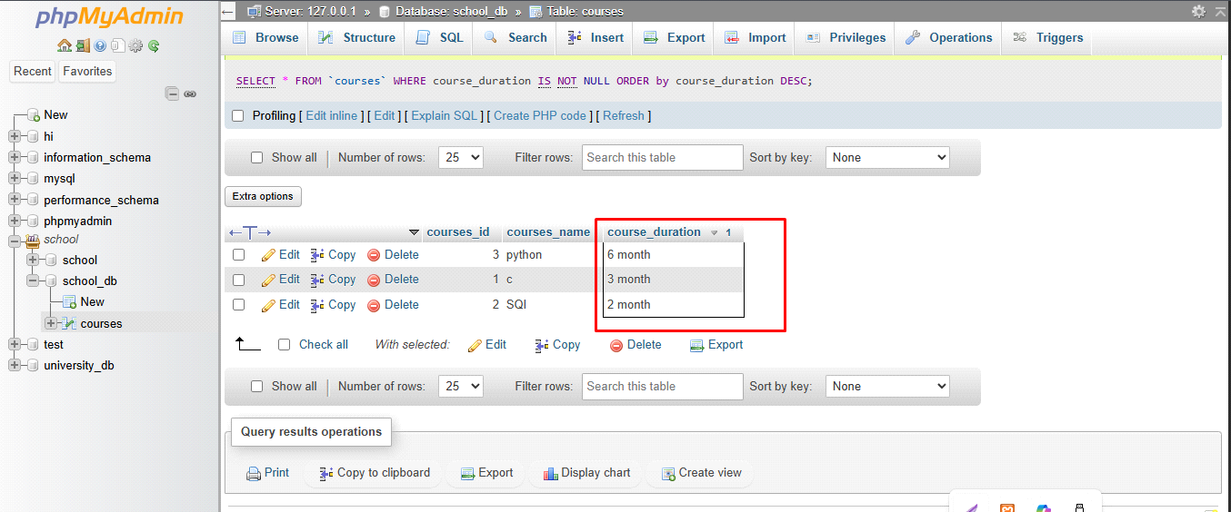

Lab 3: Limit the results of the SELECT query to show only the top two courses using LIMIT.
- SELECT * FROM courses
ORDER BY course_duration ASC
LIMIT 2;

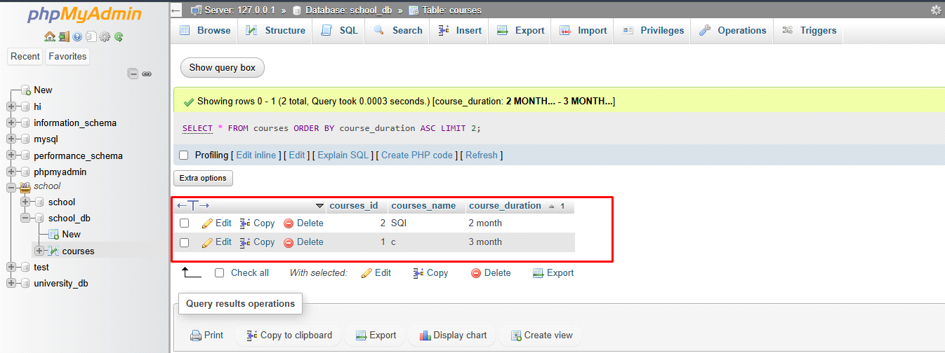
11. SQL Joins
Lab 1: Create two tables: departments and employees. Perform an INNER JOIN to display employees along with their respective departments.
- CREATE DATABASE office;
- CREATE TABLE departments
(
d_id int AUTO_INCREMENT PRIMARY KEY,
d_name varchar(20)
);
- INSERT INTO departments(d_name)
VALUES
('HR'),
('Manager'),
('sales'),
('front-end'),
('Back-end');
('Full stack'),
('Tester');

- CREATE TABLE employees
(
e_id int PRIMARY key AUTO_INCREMENT,
e_name varchar(20),
e_salary decimal(10, 2),
d_id int,
FOREIGN key (d_id) REFERENCES departments(d_id)
);
- INSERT INTO employees(e_name, e_salary, d_id)
VALUES
('Bhavesh', '25000', 1),
('Rohan', '30000', 2),
('Kishan', '28000', 3),
('Keyur', '22000', 4),
('Tushar', '23000', 5);
SELECT
employees.e_id,
employees.e_name,
departments.d_name
FROM employees
INNER JOIN departments
ON employees.e_id = departments.d_id;
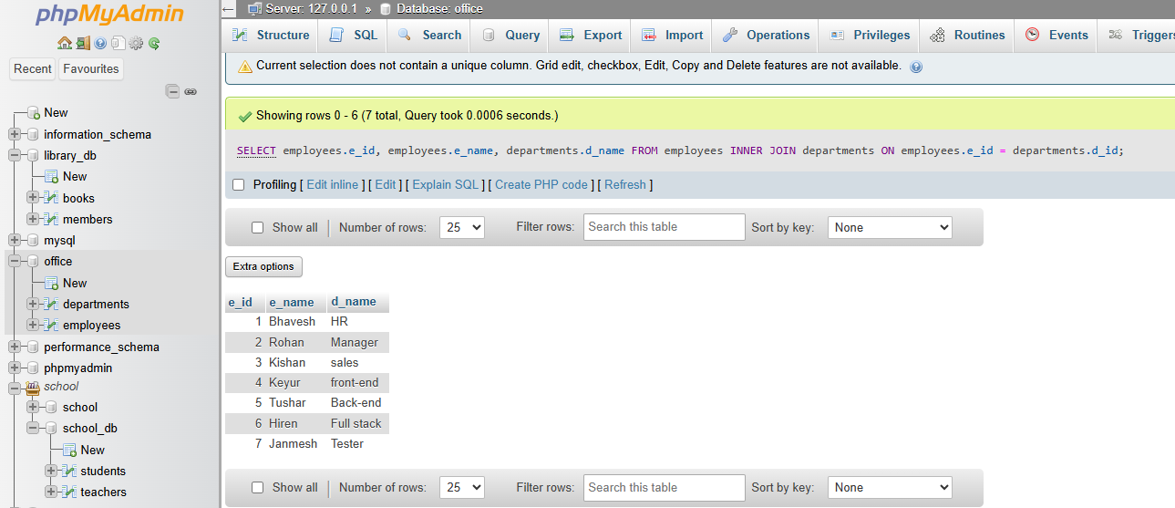

Lab 2: Use a LEFT JOIN to show all departments, even those without employees
- SELECT
employees.e_id,
employees.e_name,
departments.d_name
FROM departments
LEFT JOIN employees
ON departments.d_id = employees.e_id;
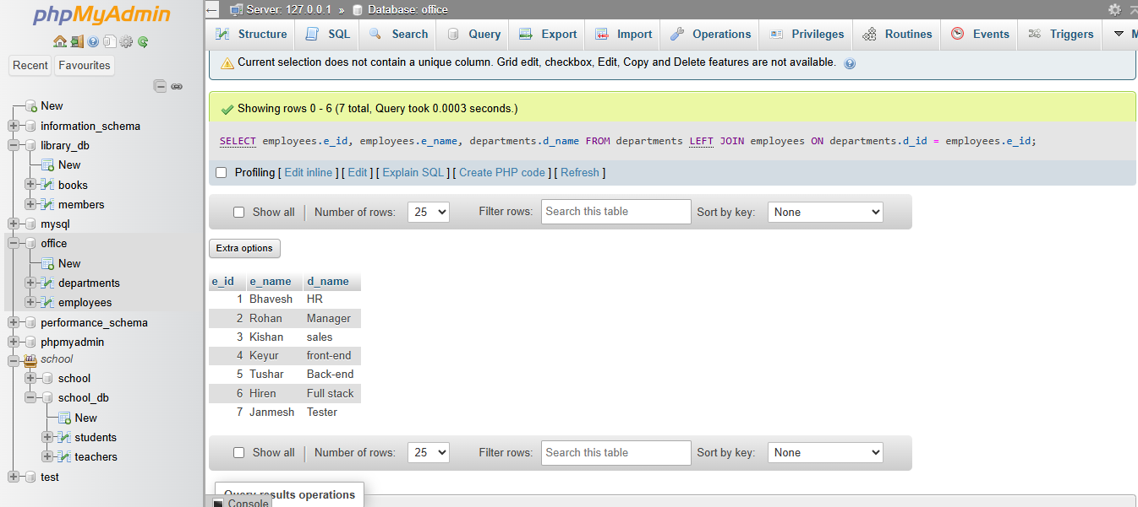

- SQL Group By
Lab 1: Group employees by department and count the number of employees in each department using GROUP BY.
Ans.
SELECT d.d_name AS department_name, COUNT(e.d_id) AS total_employees
FROM employees e
JOIN departments d ON e.d_id = d.d_id
GROUP BY d.d_name;
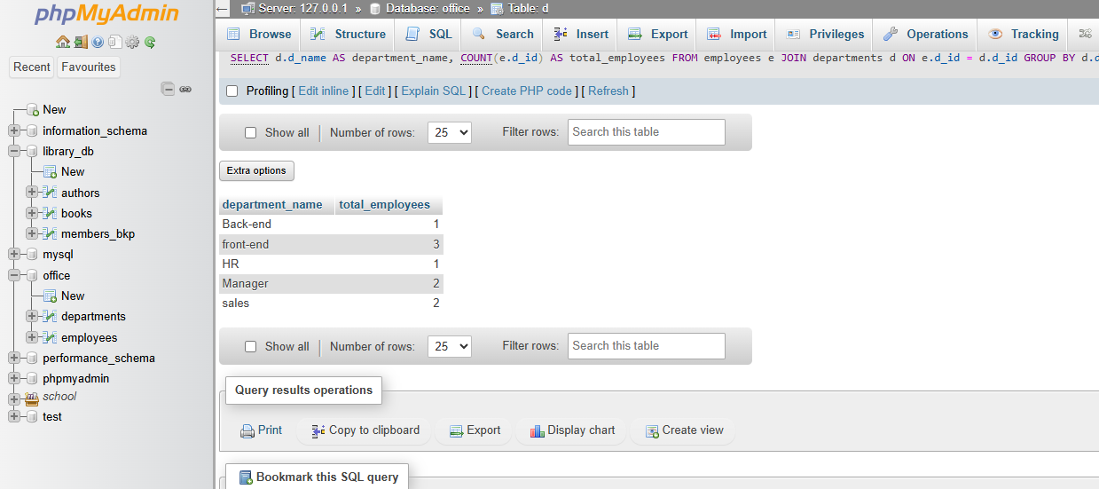

Lab 2: Use the AVG aggregate function to find the average salary of employees in each department.
Ans.
SELECT d.d_name AS department_name, AVG(e.e_salary) AS total_employees
FROM employees e
JOIN departments d ON e.d_id = d.d_id
GROUP BY d.d_name;
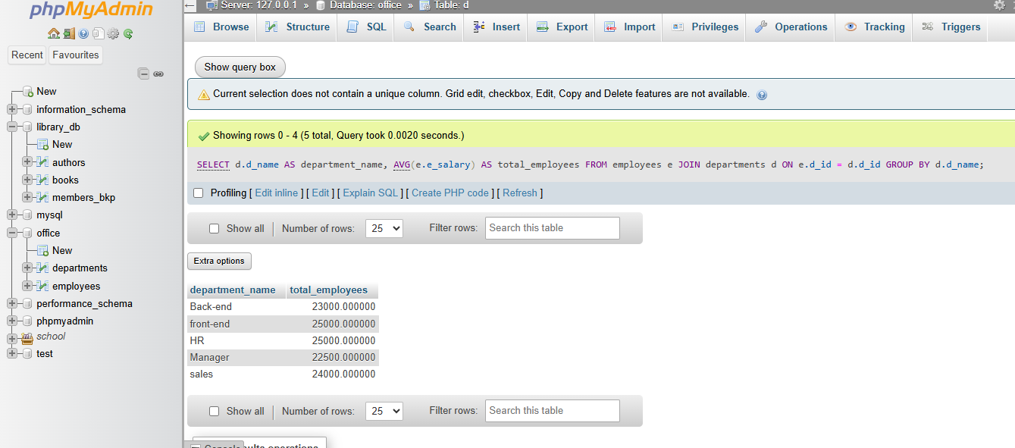

- SQL Stored Procedure
Lab 1: Write a stored procedure to retrieve all employees from the employees table based on department.
Ans.
DELIMITER //

CREATE PROCEDURE getallempwithdep()
BEGIN
SELECT e.* , d.d_name
FROM employees e
JOIN departments d ON e.d_id = d.d_id;
END //

DELIMITER ;
CALL getallempwithdep();
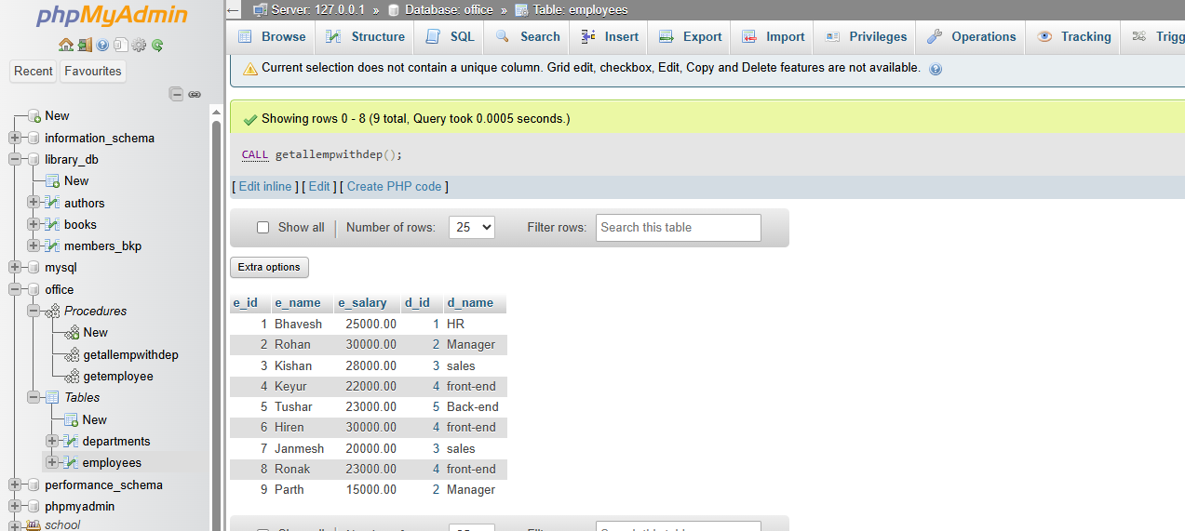

Lab 2: Write a stored procedure that accepts course_id as input and returns the course details
Ans.
DELIMITER //

CREATE PROCEDURE GetCourseDetails(IN c_id INT)
BEGIN
SELECT *
FROM courses
WHERE course_id = c_id;
END //

DELIMITER ;
call GetCourseDetails(1);
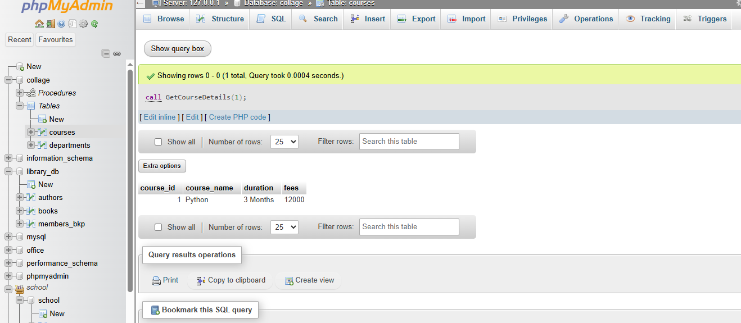
- SQL View
Lab 1: Create a view to show all employees along with their department names.
Ans.
CREATE VIEW emp_with_dep AS
SELECT e.*, d_name AS department_name
FROM employees e
LEFT JOIN departments d
ON e.d_id = d.d_id;
- SELECT * FROM emp_with_dep;
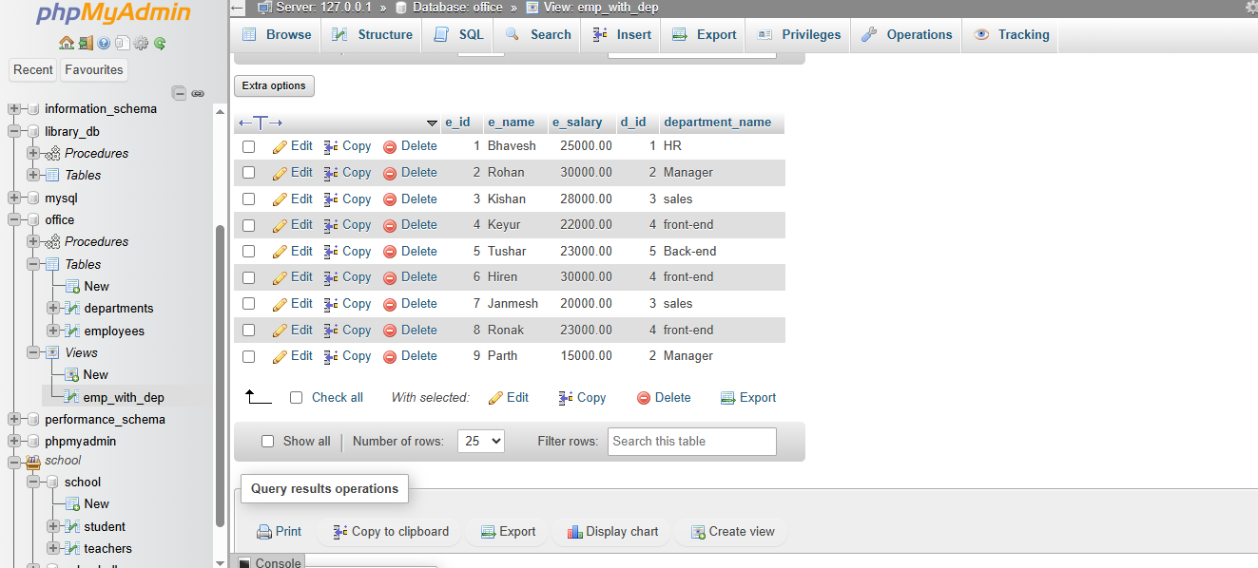

Lab 2: Modify the view to exclude employees whose salaries are below $50,000.
Ans.
- CREATE OR REPLACE VIEW employee_view AS
SELECT
e.e_id,
e.e_name,
e.e_salary,
e.d_id
FROM departments d
LEFT JOIN employees e
ON d.d_id = e.d_id
WHERE e.e_salary >= 50000;
- SELECT * FROM emp_with_dep
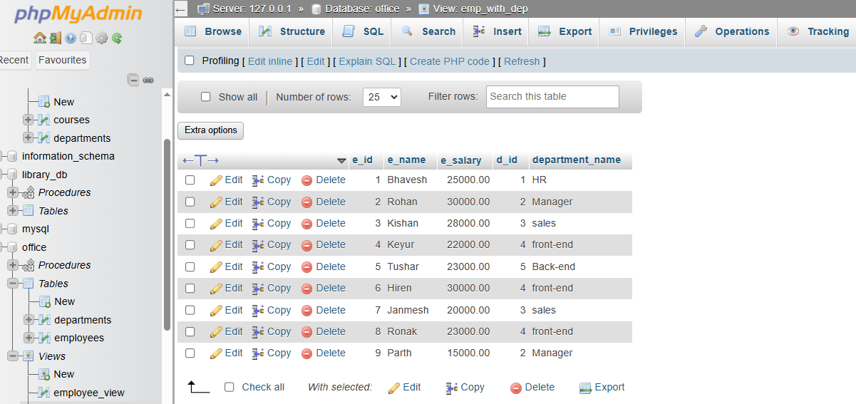

- SQL Triggers
Lab 1: Create a trigger to automatically log changes to the employees table when a new employee is added.
Ans.
- CREATE TABLE employee_log(
log_id int PRIMARY KEY AUTO_INCREMENT,
action_type varchar(20),
e_id int,
e_name varchar(50),
e_salary decimal(10,2),
e_age int,
log_time timestamp DEFAULT CURRENT_TIMESTAMP
);
- DELIMITER //

CREATE TRIGGER log_employee_insert
AFTER INSERT ON employee
FOR EACH ROW
BEGIN
INSERT INTO employee_log(action_type, e_id, e_name, e_salary, e_age)
VALUES
('INSERT', New.e_id, New.e_name, New.e_salary, New.e_age);

END //

DELIMITER ;

- INSERT INTO employee( e_name, e_salary,e_age)
VALUE
('Dhruvil Goswami',40000,26);
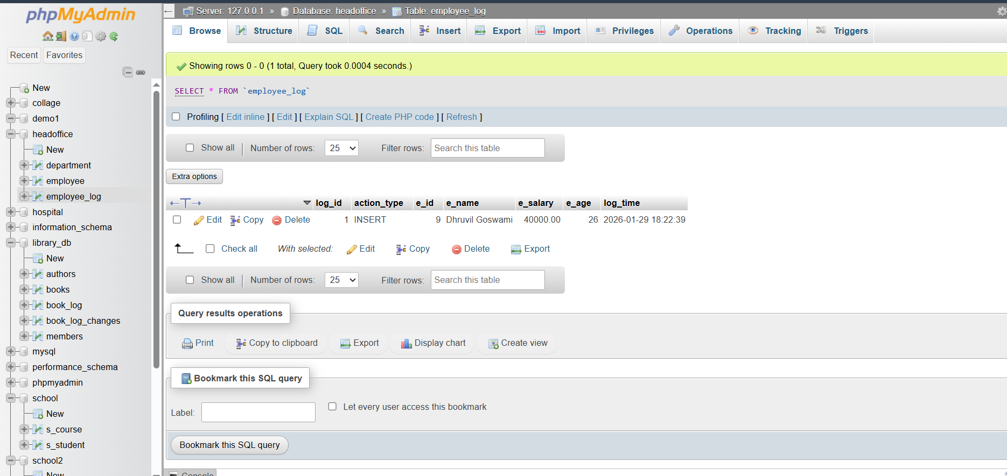

Lab 2: Create a trigger to update the last_modified timestamp whenever an employee record is updated.
Ans.
- CREATE TABLE updated_employees (
log_id int PRIMARY KEY AUTO_INCREMENT,
action_type varchar(50),
e_id INT,
e_name varchar(50),
e_salary decimal(10,2),
e_age int,
updated_time timestamp DEFAULT CURRENT_TIMESTAMP
);
DELIMITER //

CREATE TRIGGER log_employee_update
AFTER UPDATE ON employee
FOR EACH ROW
BEGIN
INSERT INTO updated_employees(action_type, e_id, e_name, e_salary, e_age)
VALUES
('UPDATE', NEW.e_id, NEW.e_name, NEW.e_salary, NEW.e_age);
END //

DELIMITER ;

- UPDATE employee
SET e_salary = 60000
WHERE e_id = 2;
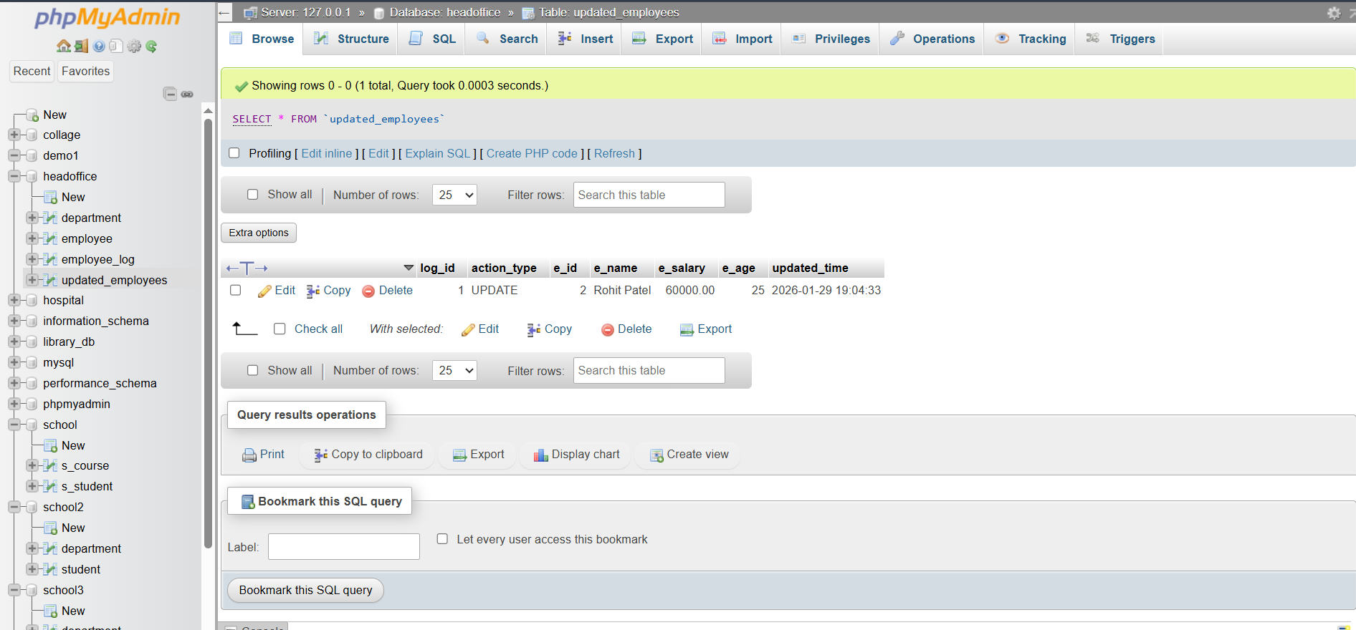

EXTRA LAB PRACTISE FOR DATABASE CONCEPTS
1. Introduction to SQL
Lab 3: Create a database called library_db and a table books with columns: book_id, title, author, publisher, year_of_publication, and price. Insert five records into the table.
- CREAT DATABASE library_db;
- CREATE TABLE books
(
book_id int PRIMARY KEY AUTO_INCREMENT,
b_title varchar(50),
b_author varchar(20),
b_publisher varchar(20),
b_year_of_publication int,
b_price int
);
- INSERT INTO books
(b_title, b_author, b_publisher, b_year_of_publication, b_price)
VALUES
('Python Basics', 'Bhavesh', 'TechPress', 2012, 240),
('Learn SQL', 'Ketan', 'CodeHouse', 2014, 200),
('Web design', 'Janak', 'Knowledge Hub', 2016, 240),
('Data science', 'Manyank', 'SmartBooks', 2018, 240),
('Java', 'Vipul', 'FutureReads', 2022, 240);
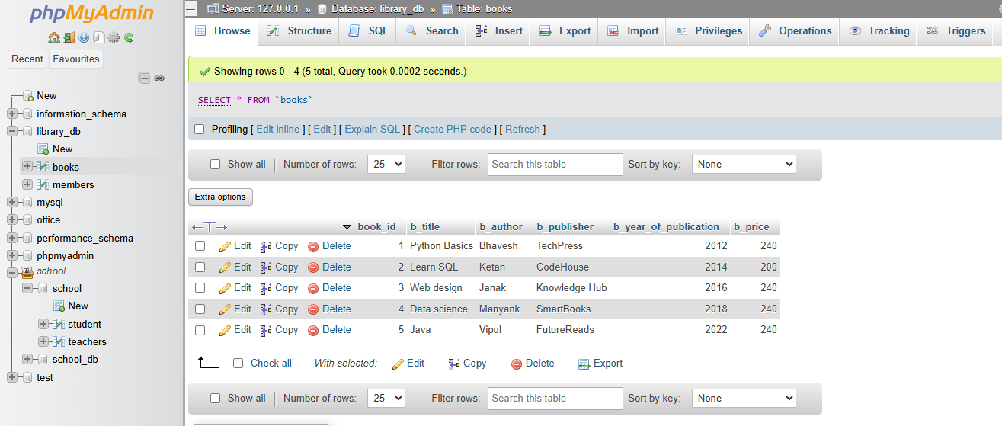
Lab 4: Create a table members in library_db with columns: member_id, member_name, date_of_membership, and email. Insert five records into this table.
- CREATE DATABASE library_db;
- CREATE TABLE members (
member_id INT PRIMARY KEY,
member_name VARCHAR(50) NOT NULL,
date_of_membership DATE NOT NULL,
email VARCHAR(100) NOT NULL
);
- INSERT INTO members (member_id, member_name, date_of_membership, email)
VALUES
(1, 'Bhavesh', '2021-01-31', 'bhavesh@gmail.com'),
(2, 'Rajesh', '2021-02-25', 'rajesh@gmail.com'),
(3, 'Mohan', '2021-03-02', 'mohan@gmail.com'),
(4, 'Kamal', '2021-05-06', 'kamal@gmail.com'),
(5, 'Tushar', '2021-03-08', 'tushar@gmail.com');
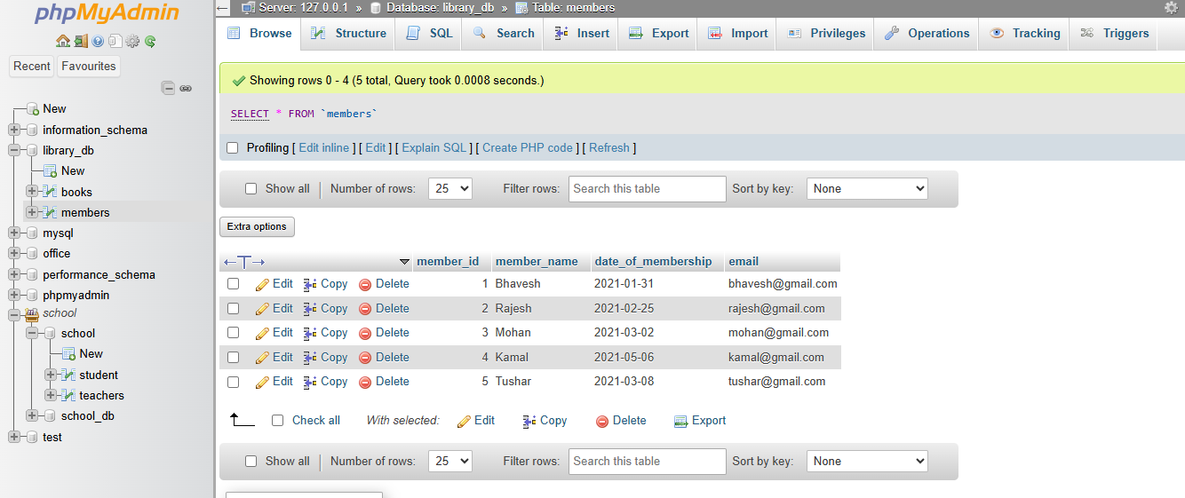

2. SQL Syntax
Lab 3: Retrieve all members who joined the library before 2022. Use appropriate SQL syntax with WHERE and ORDER BY.
Ans.
SELECT * FROM members
WHERE date_of_membership < '2022-01-01'
ORDER BY date_of_membership ASC;
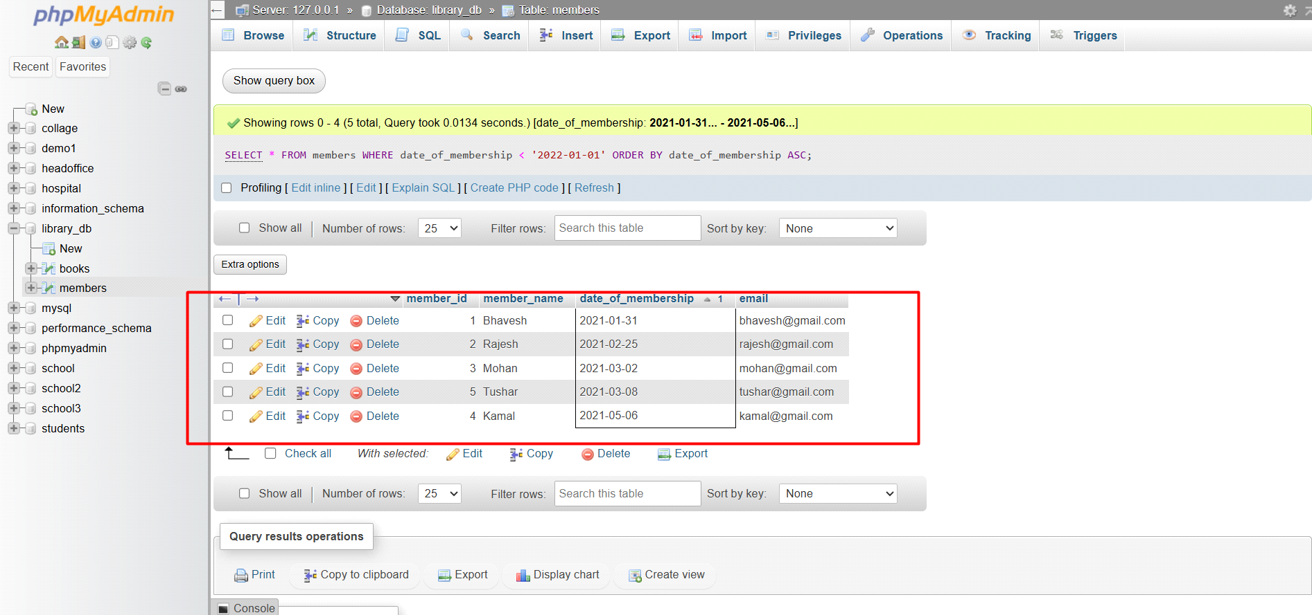
Lab 4: Write SQL queries to display the titles of books published by a specific author. Sort the
results by year_of_publication in descending order.
Ans.
SELECT b_title FROM `books`
WHERE b_author = 'Bhavesh'
ORDER BY b_year_of_publication DESC;
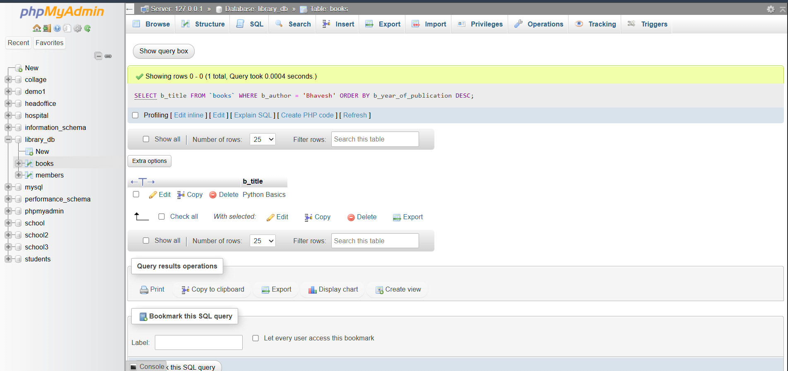

3. SQL Constraints
Lab 3: Add a CHECK constraint to ensure that the price of books in the books table is
greater than 0.
Ans.
ALTER TABLE books
ADD CONSTRAINT Check_price
CHECK (b_price > 0);
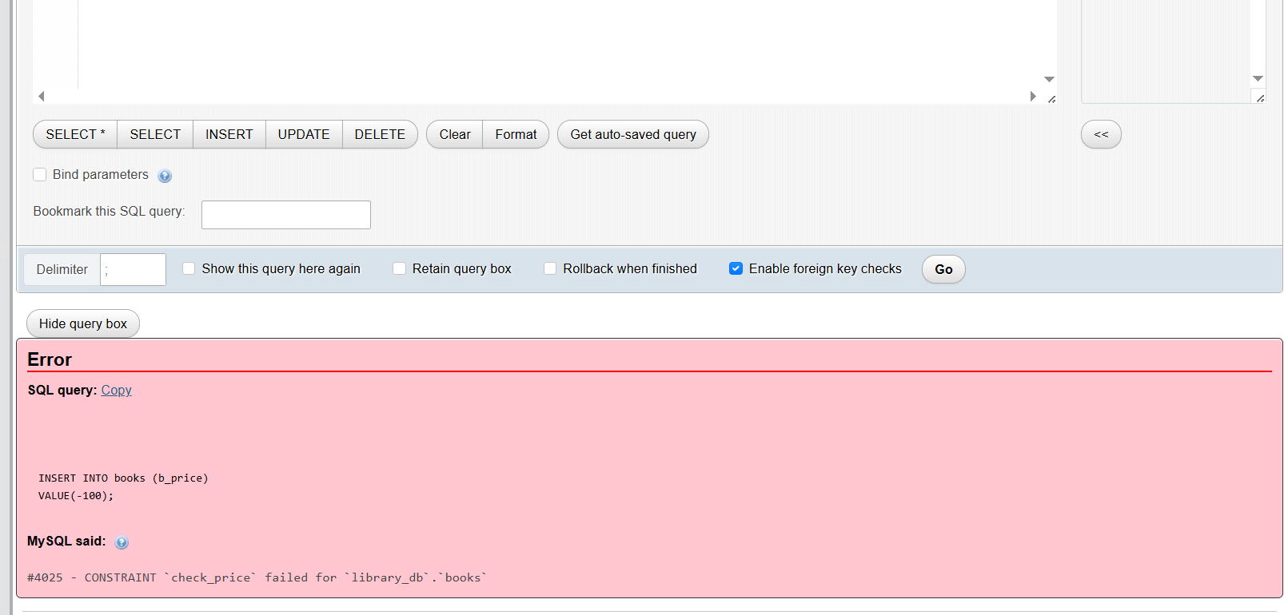

Lab 4: Modify the members table to add a UNIQUE constraint on the email column,
ensuring that each member has a unique email address.
Ans.
ALTER TABLE members
ADD CONSTRAINT UNIQUE_EMAIL
UNIQUE (email);
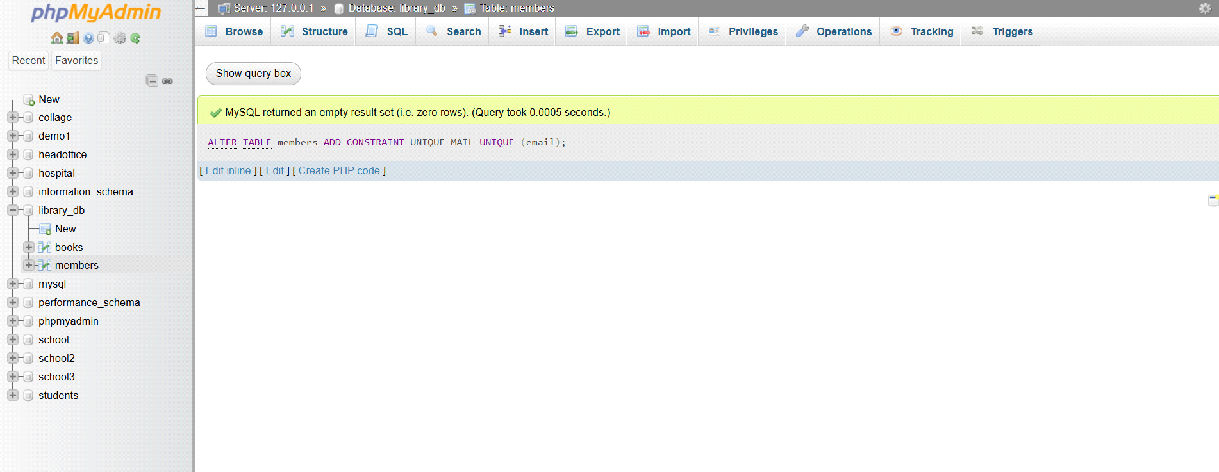

4. Main SQL Commands and Sub-commands (DDL)
Lab 3: Create a table authors with the following columns: author_id, first_name,
last_name, and country. Set author_id as the primary key.
Ans.
CREATE TABLE authors
(
author_id int AUTO_INCREMENT PRIMARY KEY,
a_first_name varchar(50),
a_last_name varchar(50),
a_country varchar(20)
);
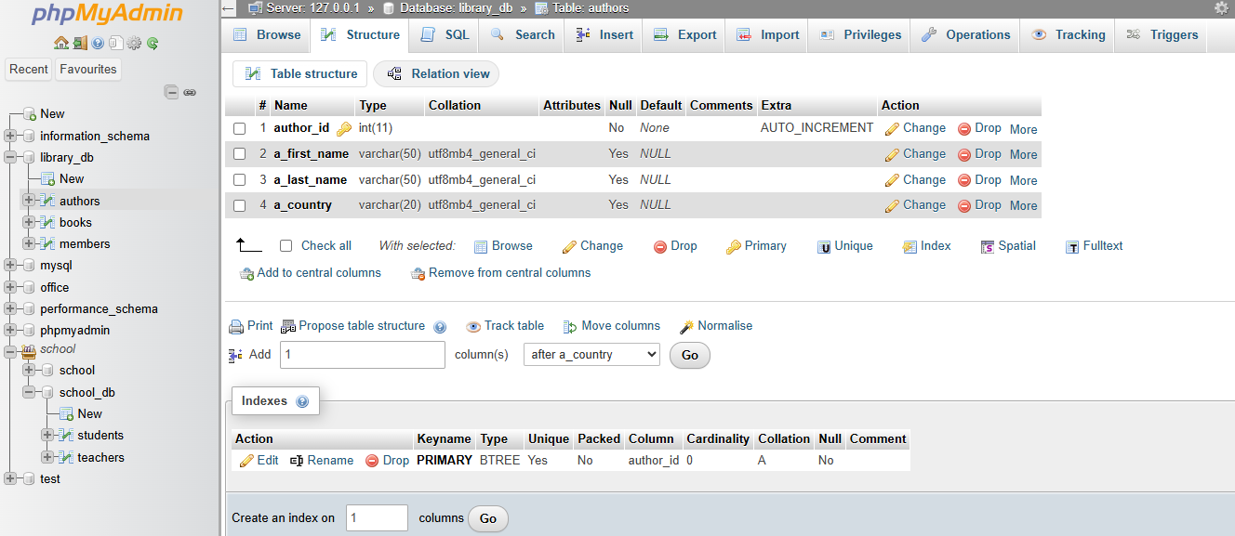

Lab 4: Create a table publishers with columns: publisher_id, publisher_name,
contact_number, and address. Set publisher_id as the primary key and
contact_number as unique.
Ans.
CREATE TABLE publishers
(
publisher_id int AUTO_INCREMENT PRIMARY KEY,
publisher_name varchar(50),
address varchar(100),
contact_number varchar(15) UNIQUE
);
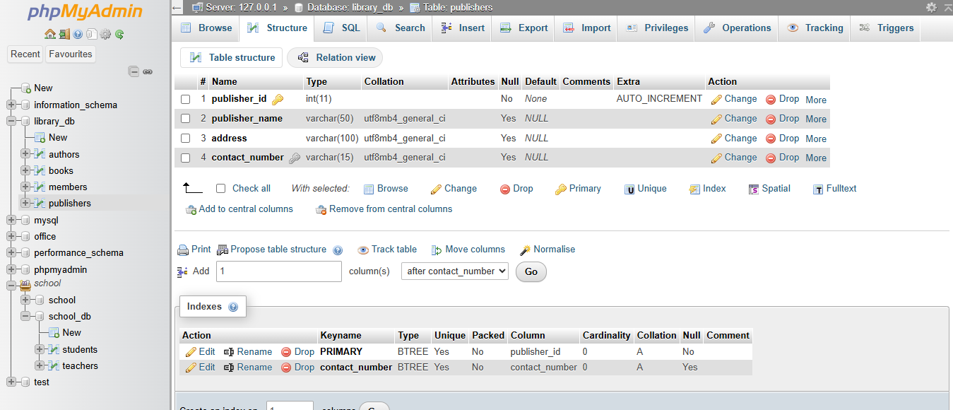

5. ALTER Command
Lab 3: Add a new column genre to the books table. Update the genre for all existing
records.
Ans.
- ALTER TABLE books
ADD COLUMN genre varchar(50);
- UPDATE books
SET genre = CASE
WHEN book_id = 1 THEN 'Programming'
WHEN book_id = 2 THEN 'SQL'
WHEN book_id = 3 THEN 'Web'
WHEN book_id = 4 THEN 'Data Science'
WHEN book_id = 5 THEN 'Programming'
END
WHERE book_id IN (1,2,3,4,5);
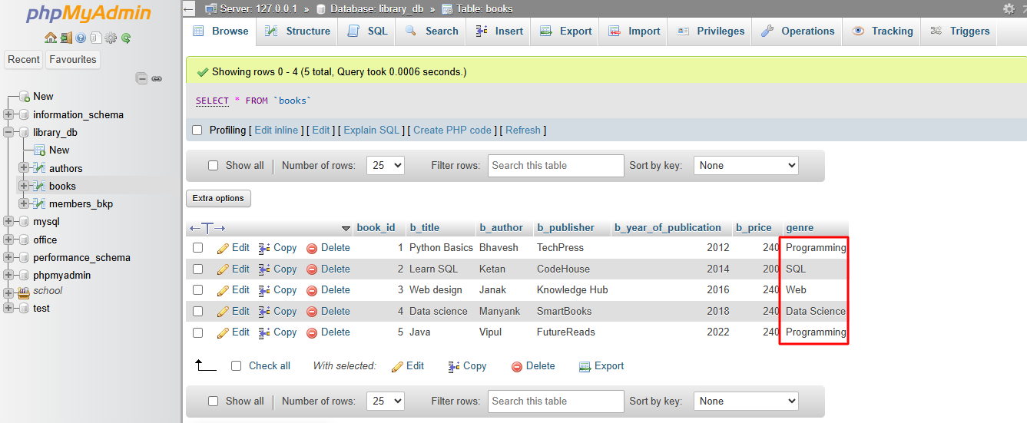

Lab 4: Modify the members table to increase the length of the email column to 100
characters.
Ans.
- ALTER TABLE members
- MODIFY email varchar(100);
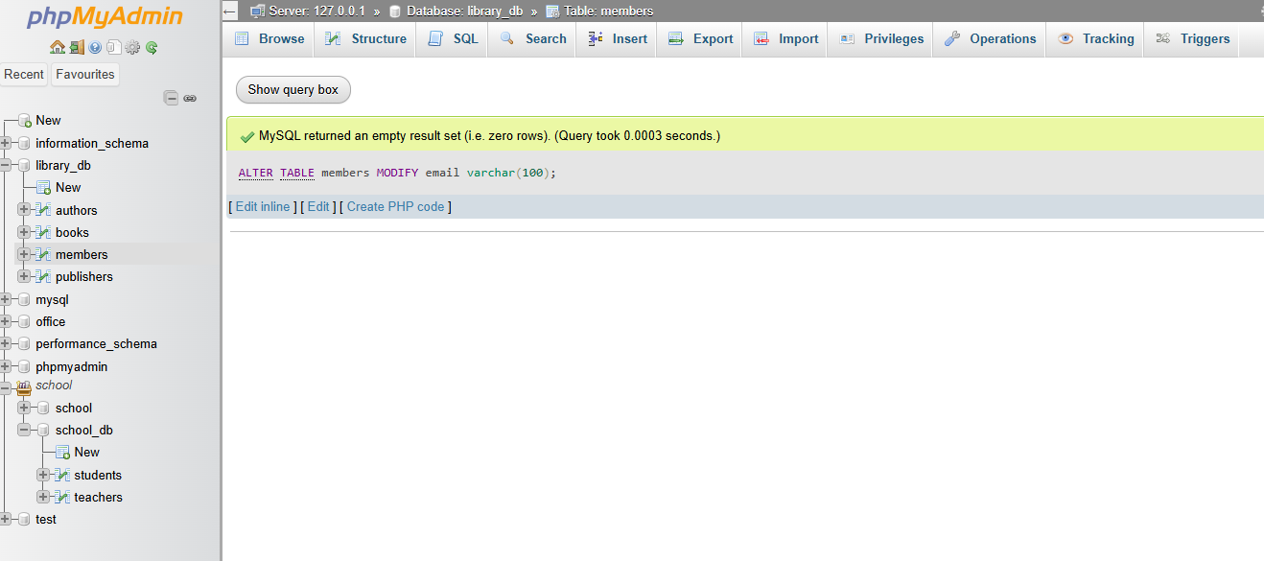

6. DROP Command
Lab 3: Drop the publishers table from the database after verifying its structure.
Ans.
- DROP TABLE publishers;
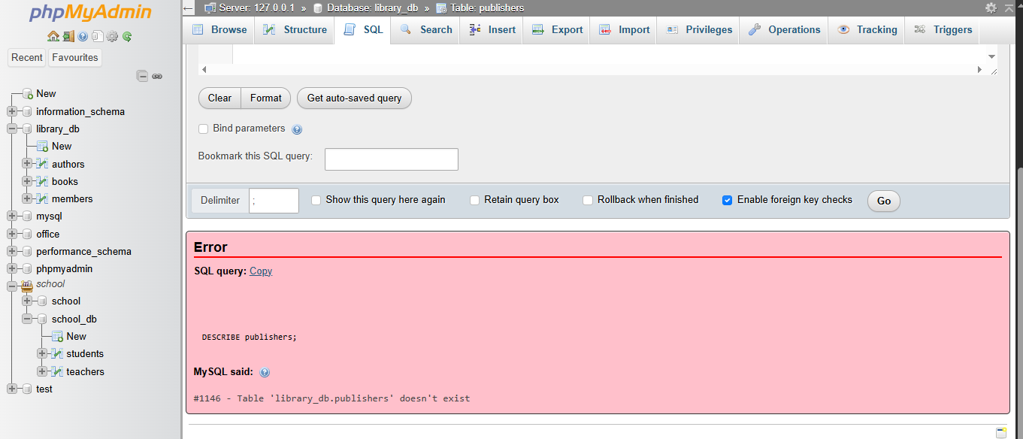

Lab 4: Create a backup of the members table and then drop the original members table.
- CREATE TABLE members_bkp AS
SELECT * FROM members;

- SELECT * FROM members_bkp;
DROP TABLE members;
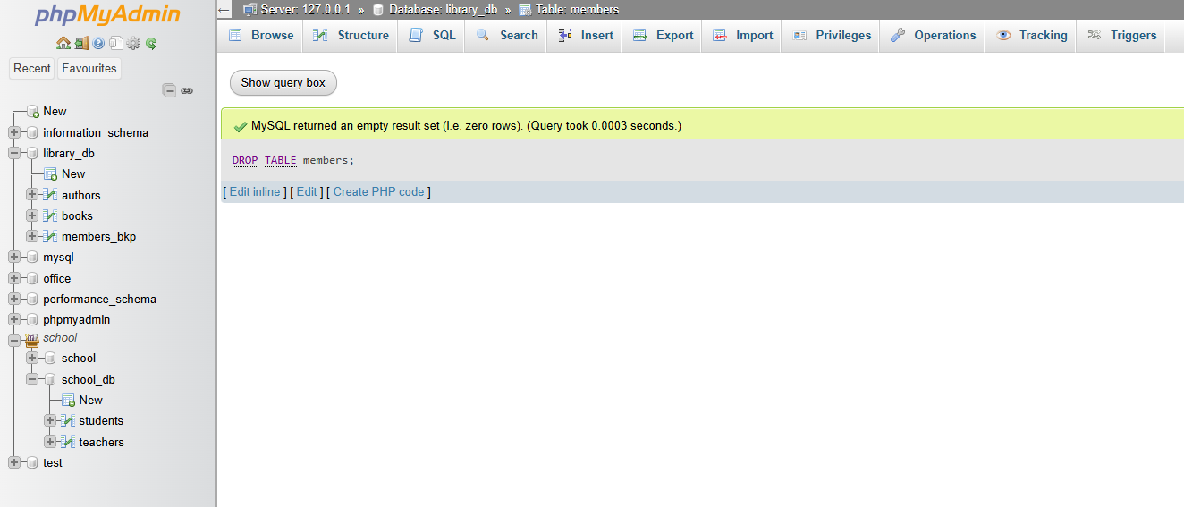
7. Data Manipulation Language (DML)
Lab 4: Insert three new authors into the authors table, then update the last name of one of the authors.
Ans.
- INSERT INTO authors(a_first_name, a_last_name, a_country)
VALUES
('Mohan', 'Roy','India'),
('Ravi', 'Patel','India'),
('Ajay', 'Pal','India');

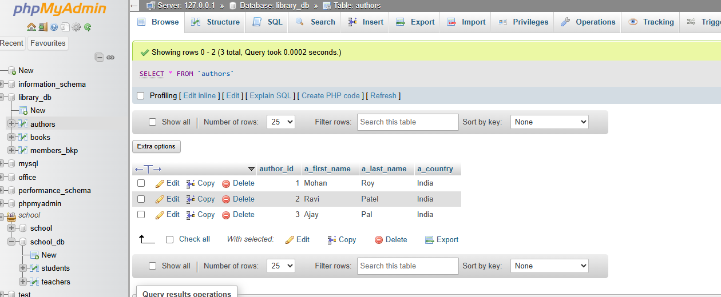
- UPDATE authors
set a_last_name = 'Patel'
WHERE author_id = 3;
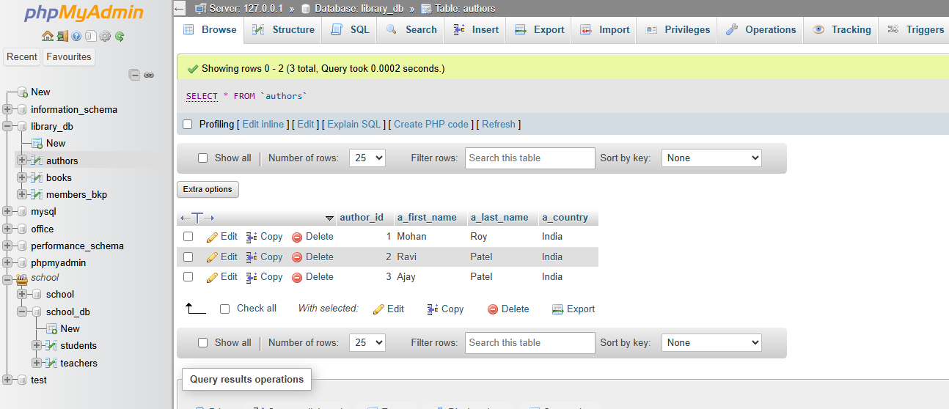

Lab 5: Delete a book from the books table where the price is higher than $100.
Ans.
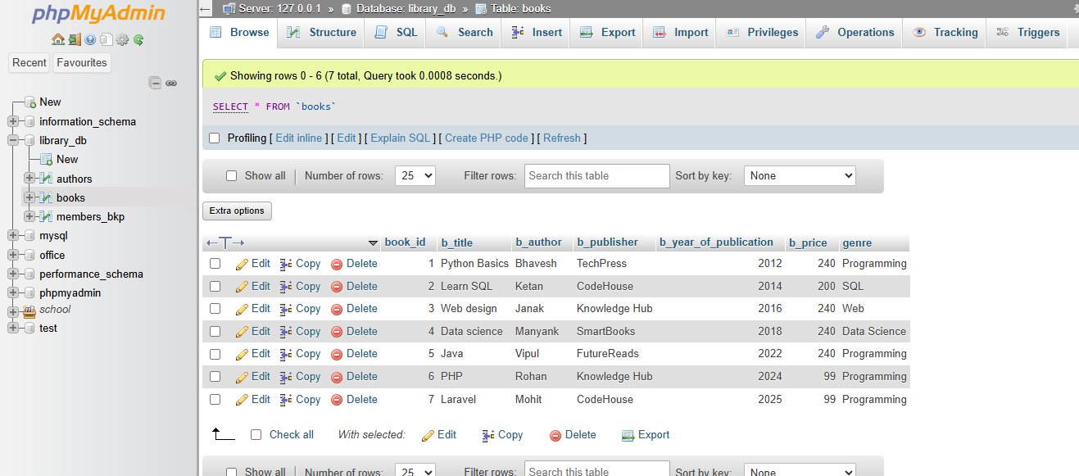
- DELETE FROM books
WHERE b_price > 100;
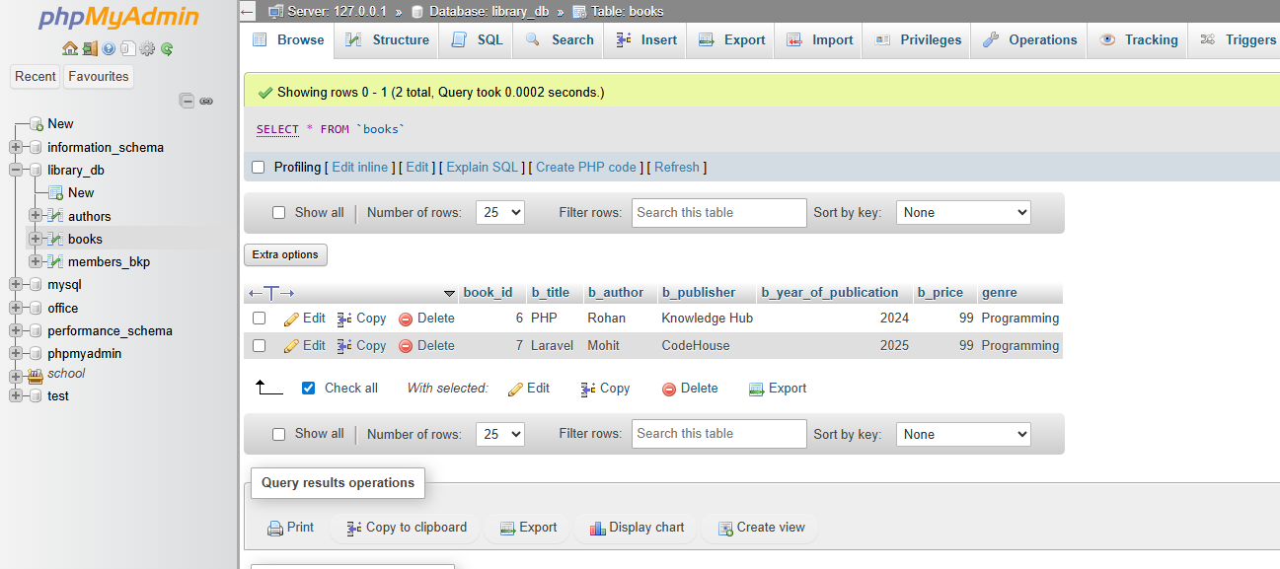

8. UPDATE Command
Lab 3: Update the year_of_publication of a book with a specific book_id.
Ans.
UPDATE books
SET b_year_of_publication = 2026
WHERE book_id = 6;
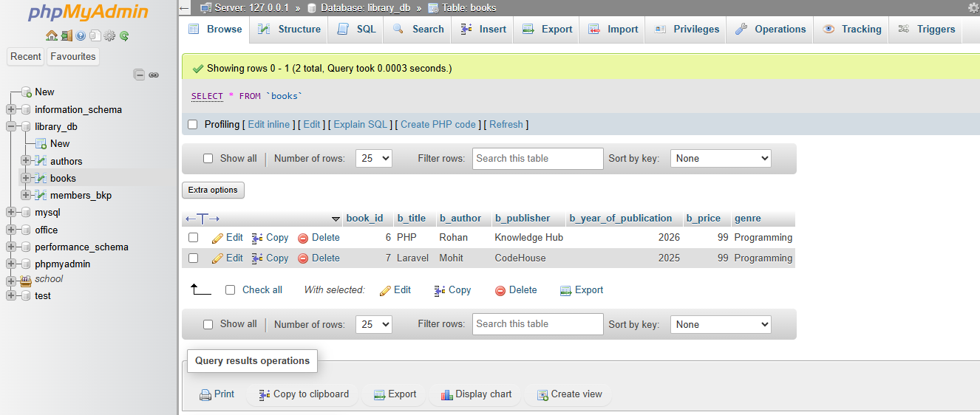

Lab 4: Increase the price of all books published before 2015 by 10%.
Ans.
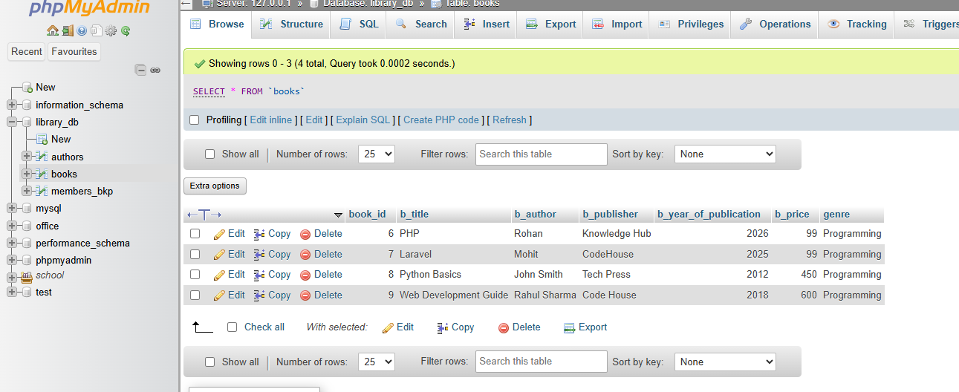
UPDATE books
SET b_price = b_price * 1.10
WHERE b_year_of_publication < 2015;
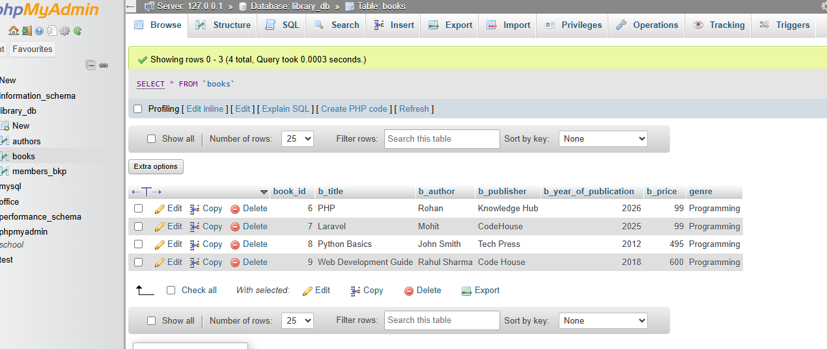
9. DELETE Command
Lab 3: Remove all members who joined before 2020 from the members table.
Ans.
DELETE FROM members_bkp
WHERE date_of_membership < 2020;
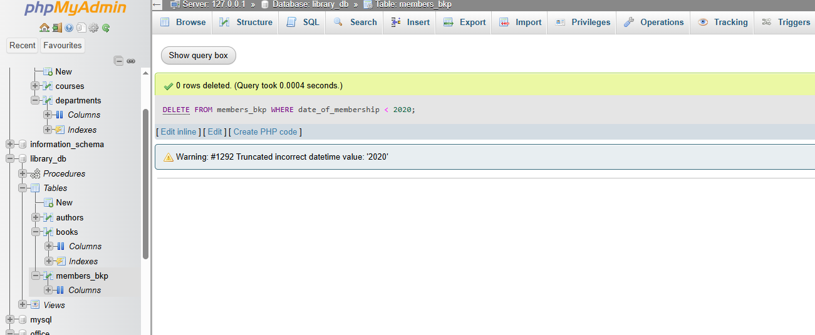

Lab 4: Delete all books that have a NULL value in the author column.
Ans.
DELETE FROM books
WHERE b_year_of_publication IS NULL;
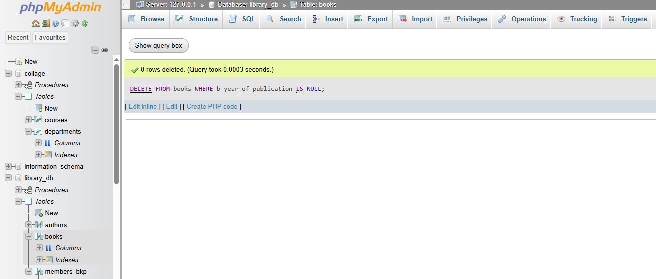

10. Data Query Language (DQL)
Lab 4: Write a query to retrieve all books with price between $50 and $100.
Ans.
SELECT * FROM books
WHERE b_price BETWEEN 50 AND 100;
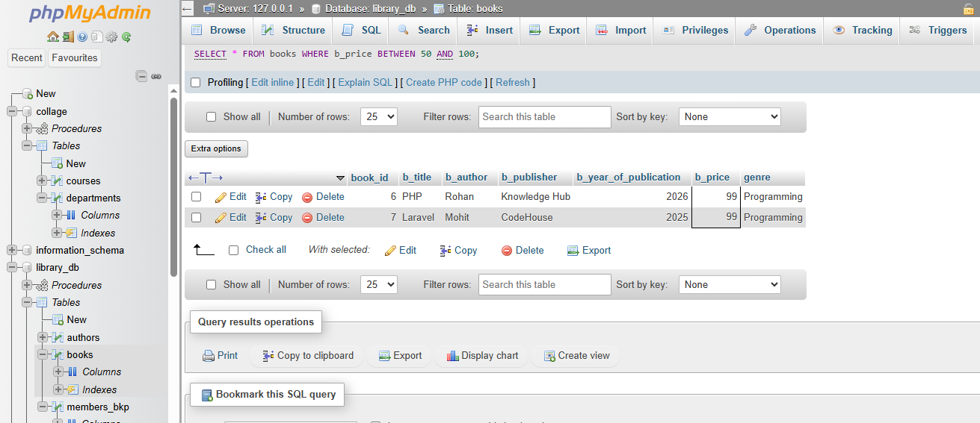

Lab 5: Retrieve the list of books sorted by author in ascending order and limit the results to the top 3 entries.
Ans.
SELECT * FROM books
ORDER BY b_author ASC
LIMIT 3;
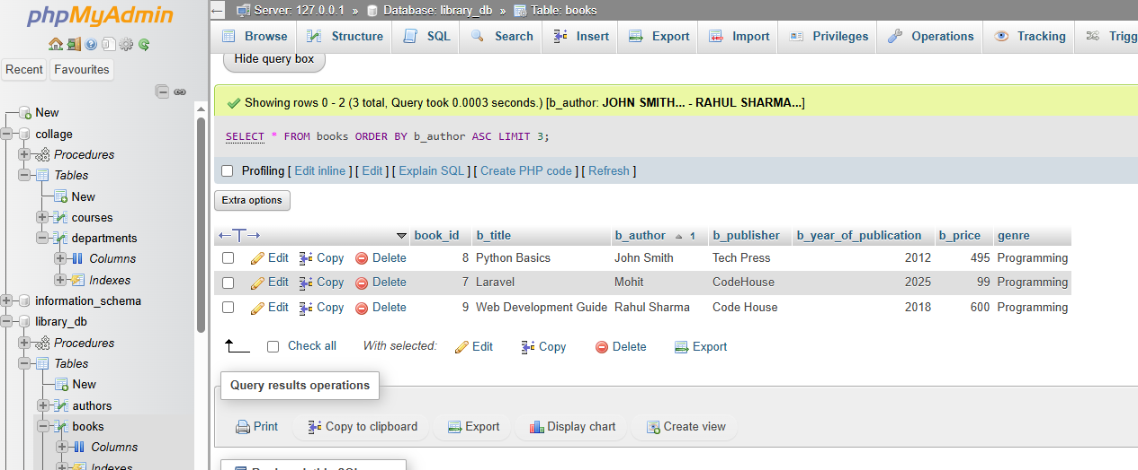

14. SQL Joins
Lab 3: Perform an INNER JOIN between books and authors tables to display the title of books and their respective authors' names.
Ans.
SELECT
books.b_title,
authors.first_name,
authors.last_name
FROM books
INNER JOIN authors
ON books.author_id = authors.author_id;
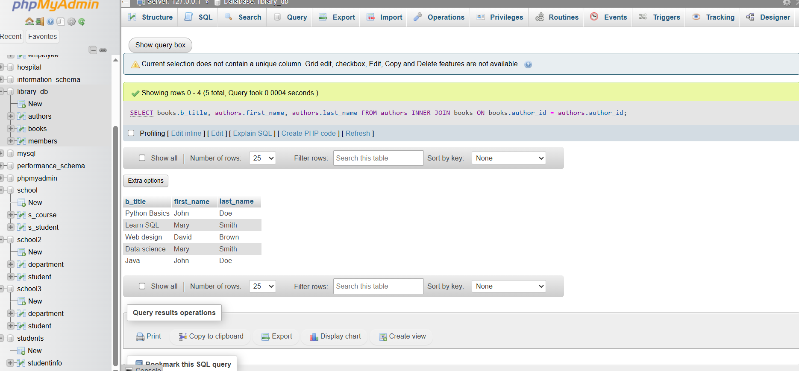

Lab 4: Use a FULL OUTER JOIN to retrieve all records from the books and authors tables, including those with no matching entries in the other table.
Ans.
SELECT
books.book_id,
books.b_title,
books.b_publisher,
books.b_year_of_publication,
books.b_price,
books.genre,
authors.author_id as author_id,
authors.first_name,
authors.last_name,
authors.email
FROM books
LEFT JOIN authors
ON books.author_id = authors.author_id

UNION

SELECT
books.book_id,
books.b_title,
books.b_publisher,
books.b_year_of_publication,
books.b_price,
books.genre,
authors.author_id as author_id,
authors.first_name,
authors.last_name,
authors.email
FROM books
RIGHT JOIN authors
ON books.author_id = authors.author_id;
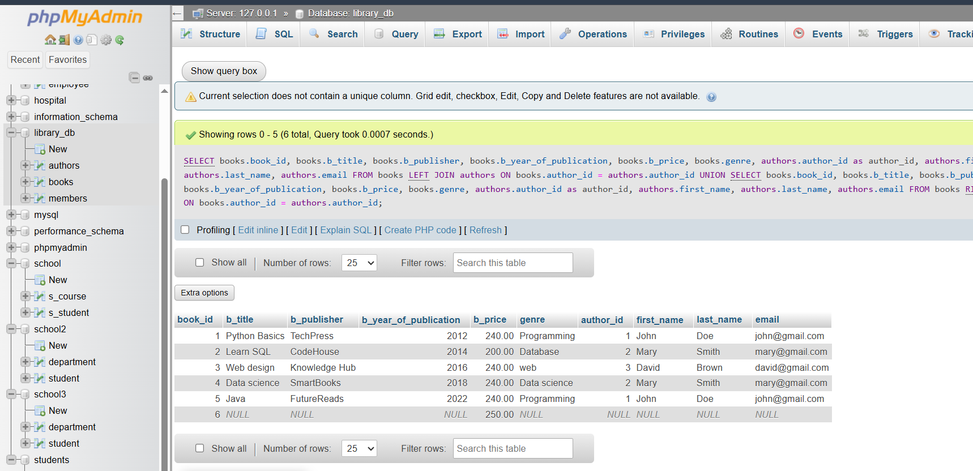

15. SQL Group By
Lab 3: Group books by genre and display the total number of books in each genre.
Ans.
SELECT genre, COUNT(*) as Total_books
FROM books
GROUP BY genre;
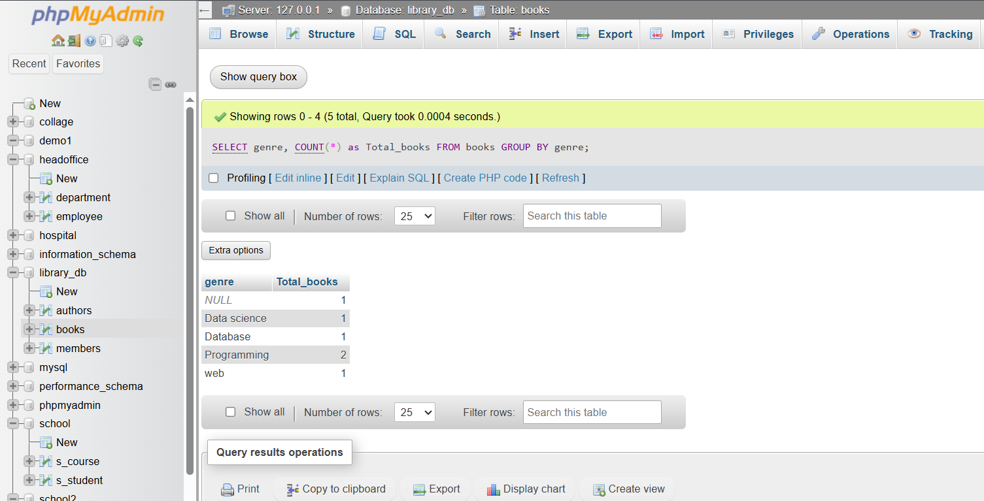

Lab 4: Group members by the year they joined and find the number of members who joined each year.
Ans.
SELECT b_year_of_publication, COUNT(*) as Total_member
FROM books
WHERE b_year_of_publication is NOT null
GROUP BY b_year_of_publication;
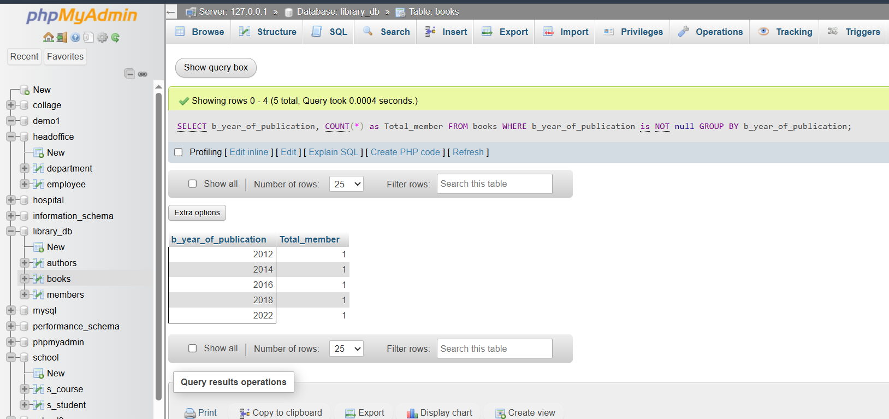

16. SQL Stored Procedure
Lab 3: Write a stored procedure to retrieve all books by a particular author.
Ans.
- DELIMITER //

CREATE PROCEDURE GetBooksByAuthor(in author_name varchar(50))
BEGIN
SELECT *
FROM books
WHERE b_author = author_name;
END //
DELIMITER ;
- CALL GetBooksByAuthor('John Smith');
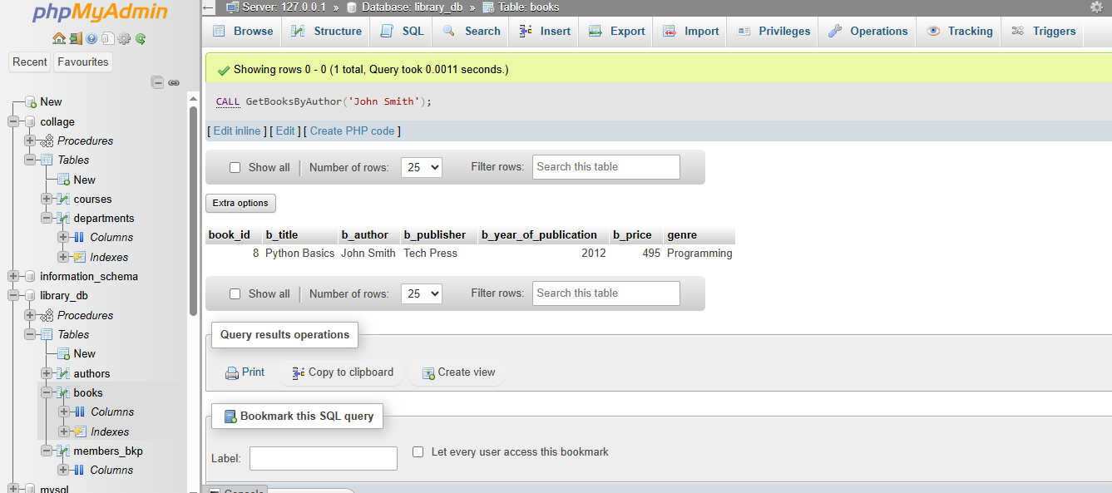

DELIMITER ;
Lab 4: Write a stored procedure that takes book_id as an argument and returns the price
of the book.
Ans.
DELIMITER //

CREATE PROCEDURE getBookPrice(in p_book_id int)
BEGIN
SELECT b_price
FROM books
WHERE book_id = p_book_id;
END //
DELIMITER ;
- CALL getBookPrice(6);
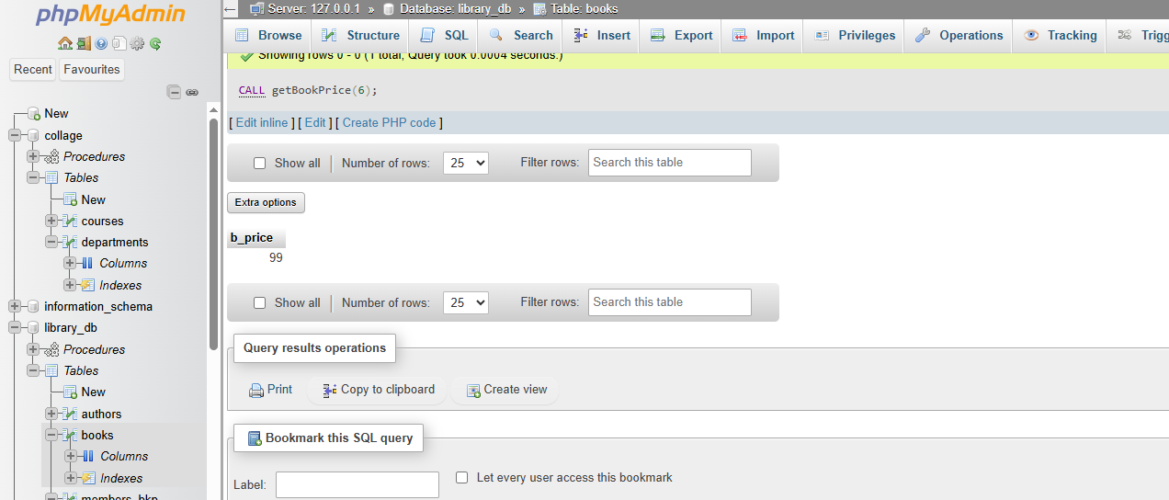
17. SQL View
Lab 3: Create a view to show only the title, author, and price of books from the books table.
Ans.
CREATE VIEW BookDetail AS
SELECT
b_title,
b_author,
b_price
FROM books;
- SELECT * FROM BookDetail;
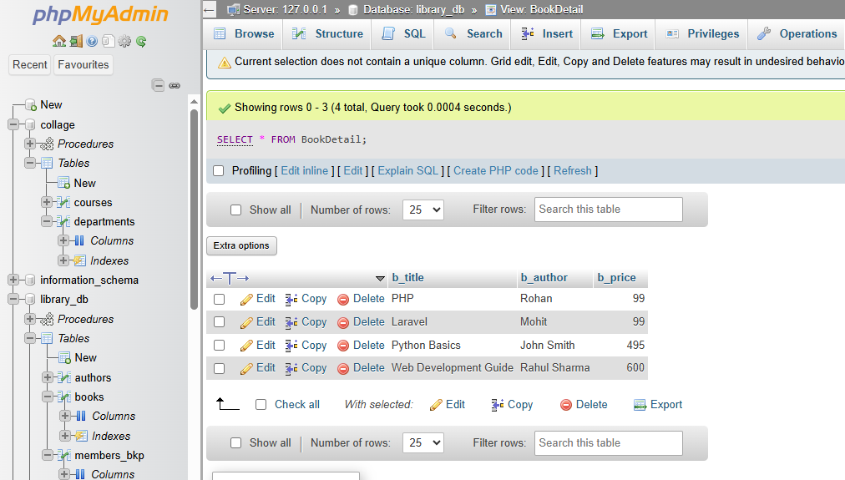

Lab 4: Create a view to display members who joined before 2020.
Ans.
CREATE VIEW membefore2020 As
SELECT
member_id,
member_name,
date_of_membership
FROM members_bkp
WHERE date_of_membership < 2020;
- SELECT * FROM membefore2020;
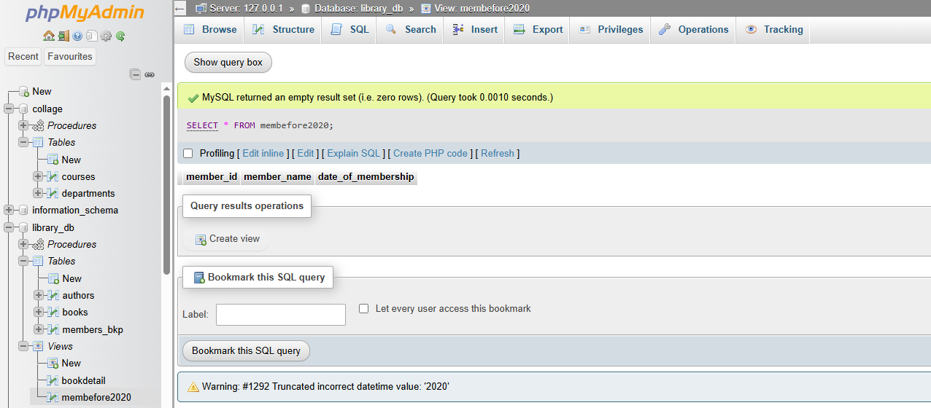

18. SQL Trigger
Lab 3: Create a trigger to automatically update the last_modified timestamp of the books table whenever a record is updated.
Ans.
- CREATE TABLE book_log (
log_id INT PRIMARY KEY AUTO_INCREMENT,
action_type VARCHAR(50),
book_id INT,
b_title VARCHAR(50),
b_author VARCHAR(50),
b_publisher VARCHAR(50),
b_year_of_publication INT,
b_price DECIMAL(10,2),
last_modified TIMESTAMP DEFAULT CURRENT_TIMESTAMP
);
- DELIMITER //

- CREATE TRIGGER log_book_update
AFTER UPDATE ON books
FOR EACH ROW
BEGIN
INSERT INTO book_log
(action_type, book_id, b_title, b_author, b_publisher, b_year_of_publication, b_price)
VALUES
('UPDATE', NEW.book_id, NEW.b_title, NEW.b_author, NEW.b_publisher,
NEW.b_year_of_publication, NEW.b_price);
END$$

DELIMITER ;

- UPDATE books
SET b_price = 300
WHERE book_id = 1;
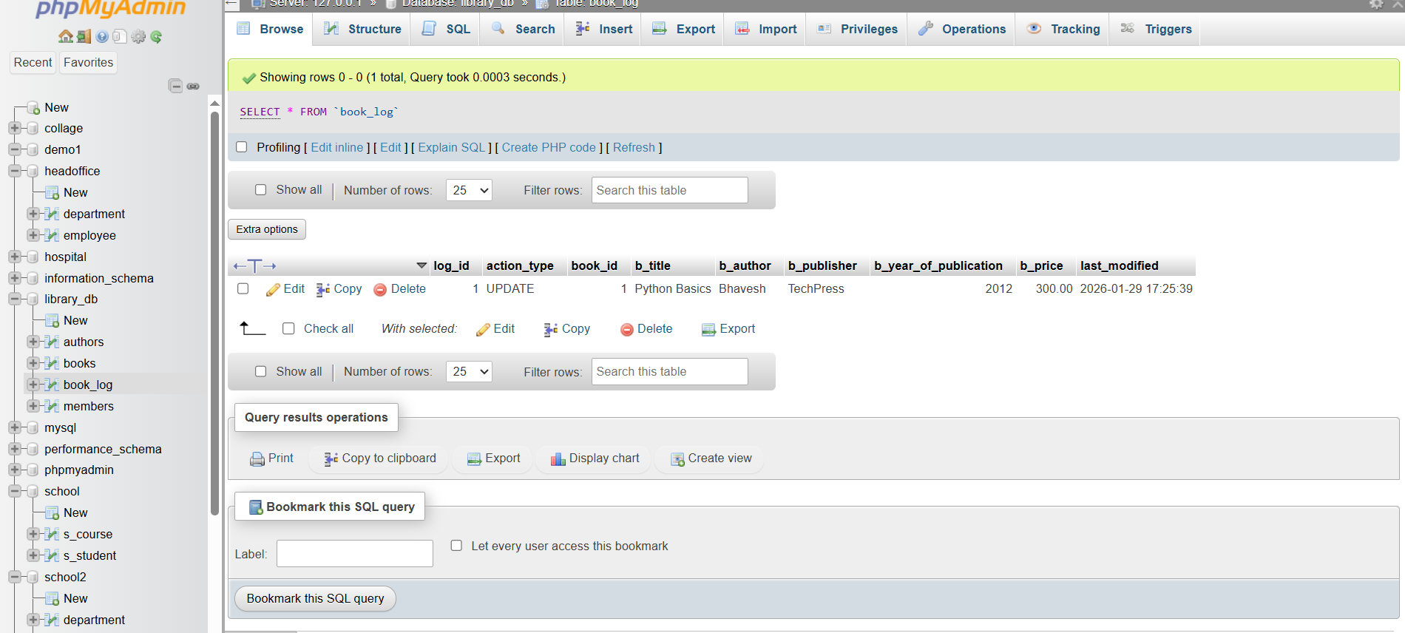

Lab 4: Create a trigger that inserts a log entry into a log_changes table whenever a DELETE operation is performed on the books table.
Ans.
CREATE TABLE book_log_changes (
log_id int PRIMARY KEY AUTO_INCREMENT,
action_type varchar(20),
book_id INT,
b_title VARCHAR(50),
b_author VARCHAR(50),
b_publisher VARCHAR(50),
b_year_of_publication INT,
b_price DECIMAL(10,2),
delete_time timestamp DEFAULT CURRENT_TIMESTAMP
)
- DELIMITER //

CREATE TRIGGER log_book_delete
AFTER DELETE ON books
for EACH ROW
BEGIN
INSERT INTO book_log_changes (action_type, book_id, b_title, b_author, b_publisher, b_year_of_publication, b_price)
VALUES ('DELETE', OLD.book_id, OLD.b_title, OLD.b_author,OLD.b_publisher, OLD.b_year_of_publication, OLD.b_price);
END //

DELIMITER ;
- DELETE FROM books
WHERE book_id = 5;

